A
MAJOR PROJECT REPORT ON

“SMART YOGA MAT USING IOT”
Submitted in partial fulfillment of the requirements for the award of the degree
BACHELOR OF TECHNOLOGY (B. TECH) IN
ELECTRONICS AND COMMUNICATION ENGINEERING
Submitted by
P.GOWTHAMI 22R95A0420 S.ANIL 22R95A0425 T.DURGA PRASAD 21R91A04N5 T.SHESHUNATH 21R91A04N3
Under the guidance of
Mrs. B. REKHA

Assistant Professor

DEPARTMENT OF ELECTRONICS AND COMMUNICATION ENGINEERING TEEGALA KRISHNA REDDY ENGINEERING COLLEGE
Medbowli, Meerpet, Saroor Nagar, Hyderabad -097 Affiliated to JNTUH, Hyderabad
May, 2025

CERTIFICATE
This is to certify that the project entitled “SMART YOGA MAT USING IOT”
submitted by P.GOWTHAMI (22R95A0420), S.ANIL (22R95A0425), T.DURGA
PRASAD (21R91A04N5), T.SHESHUNATH (21R91A04N3), in partial fulfillment of the requirements for the award of BACHELOR OF TECHNOLOGY in ELECTRONICS AND COMMUNICATION ENGINEERING in JNTUH, is a record of Bonafide work carried out under supervision and guidance.

PROJECT GUIDE
Mrs. B. REKHA
ASSISTANT PROFESSOR
HEAD OF THE DEPARTMENT | EXTERNAL EXAMINER
Dr. SK. UMAR FARUQ PROFESSOR

Date: Place:

DECLARATION
We, P.GOWTHAMI(22R95A0420), S.ANIL(22R95A0425), T.DURGA
PRASAD(21R91A04N5), T.SHESHUNATH(21R91A04N3), hereby declare that the project work entitled “SMART YOGA MAT USING IOT” submitted to the Department of ELECTRONICS AND COMMUNICATION ENGINEERING, [Teegala Krishna Reddy
Engineering College] in partial fulfillment of the requirements for the award of the degree of
BACHELOR OF TECHNOLOGY in ELECTRONICS AND COMMUNICATION
ENGINEERING by JNTUH, is a record of original work carried out by us under the guidance of Mrs. B. REKHA, Assistant Professor, during the academic year 2024-2025.
I further declare that this project has not formed the basis for the award of any degree, diploma, associate-ship, fellowship, or any other similar title or recognition previously.

Date: Place:

(Signature of the Student) (Signature of the Student)
Name: P. GOWTHAMI Name: S. ANIL
Reg. No.: 22R95A0420 Reg. No.: 2R95A0425

(Signature of the Student) (Signature of the Student)
Name: T. DURGA PRASAD Name: T. SHESHUNATH
Reg. No.: 21R91A04N5 Reg. No.: 21R91A04N3



ACKNOWLEDGEMENT

The satisfaction and euphoria that accompanies the successful completion of any task would be incomplete without the mention of the people who made it possible and whose encouragement and guidance have crowned our efforts with success.
First, we would like to thank our Major Project guide Mrs. B. REKHA, Assistant Professor in Department of E.C.E., for her inspiration, adroit guidance and constructive criticism for completion of our degree.
We would like to convey our special thanks to the Major Project Co-Ordinator Dr. P. PADMAJA, Professor in Department of E.C.E., for her valuable guidance and suggestions in analyzing and testing throughout the period, till the end of this work completion.
Also, we would like to express our sincere gratitude to Dr. SK. UMAR FARUQ, Professor Head of Department in Electronics & Communication Engineering during the progress of the Project work, for his timely suggestions and help in spite of his busy schedule. We would like to convey our special gratitude to the Vice-Principal and Dean of Academics at Teegala Krishna Reddy Engineering College Dr. B. SRINIVASA RAO,
Professor in Department of C.S.E., for his inspiration, adroit guidance and constructive criticism for completion of this work.
Our acknowledgement extended to Principal Dr. K.V. MURALI MOHAN, Principal of TEEGALA KRISHNA REDDY ENGINEERING COLLEGE for his consistent help and encouragement to complete the research work.
We are very much thankful to TKR EDUCATIONAL SOCIETY and our beloved Chairman Sri TEEGALA KRISHNA REDDY Garu for their help in providing good facilities in our college.
P.GOWTHAM 22R95A0420
S.ANIL 22R95A0425 T.DURGA PRASAD 21R91A04N5 T.SHESHUNATH 21R91A04N3

ABSTRACT

The growing popularity of wellness technologies has opened opportunities for integrating smart solutions into traditional practices like yoga. The "Smart Yoga Mat" is an innovative IoT-based system designed to enhance yoga practices by providing real-time feedback and monitoring. Using an ESP32 microcontroller, this smart mat is equipped with various sensors to track posture, environmental conditions, and user interactions. The MPR121 sensor detects touch inputs to assess hand and foot placements, while the force sensor monitors the pressure applied during poses, ensuring proper form and balance. The DS18b sensor measures body temperature, providing insights into the practitioner’s physical state, and the IR sensor tracks motion to ensure correct positioning. An LCD display presents real-time feedback on the user's performance, and the data is transmitted through IoT for remote monitoring or analysis. This smart yoga mat encourages correct postures, reduces injury risks, and enhances the overall yoga experience by combining traditional fitness with cutting- edge technology.

TABLE OF CONTENTS

ABSTRACT 1
TABLE OF CONTENTS 2
LIST OF FIGURES i
LIST OF TABLES ii
LIST OF ABBREVIATIONS iii
CHAPTER 1 1
INTRODUCTION 1
  - INTRODUCTION 1
  - OBJECTIVE OF THE PROJECT 1
CHAPTER 2 LITERATURE SURVEY 3
  - LITERATURE INTRODUCTION 3
  - MAIN CONCERNS AND REASONS: 4
    - MAIN CONCERNS: 4
    - REASONS FOR USING SPECIFIC SENSOR 5
    - RESEARCH VIEWER’S: 6
CHAPTER 3 7
SMART YOGA MAT USING IOT SYSTEM 7
  - PROPOSED SYSTEM 7
    - Working of the Proposed System 7
  - BLOCK DIAGRAM 8
  - SCHEMATIC DIAGRAM: 9
  - WORKING PRINCIPLE: 11
  - FLOW CHART: 11
CHAPTER 4 14
HARDWARE DESCRIPTION 14
HARDWARE REQUIREMENTS 14
  - IR SENSOR 14
    - Purpose of IR Sensor 14
    - IR Sensor Pin Configuration 14
    - Working of IR Sensor 15
    - Advantages of IR Sensor 16
    - Applications of IR Sensor 16
  - FORCE SENSOR 16
    - Purpose of Force Sensor 17
    - Pin Configuration of Force Sensor 17
    - Working of Force Sensor 18
    - Advantages of Force Sensor 18
    - Applications of Force Sensor 18
  - DS18B20 TEMPERATURE SENSOR 19
    - Purpose of DS18B20 Temperature Sensor 20
    - Pin Configuration of DS18B20 Temperature Sensor 20
    - Working of DS18B20 Temperature Sensor 21
    - Advantages of DS18B20 Temperature Sensor 21
    - Applications of DS18B20 Temperature Sensor 22
  - MPR121 TOUCH SENSOR 22
    - Purpose of MPR121 Touch Sensor 22
    - Pin Configuration of MPR121 Touch Sensor 22
    - Working of MPR121 Touch Sensor 23
    - Advantages of MPR121 Touch Sensor 24
    - Applications of MPR121 Touch Sensor 24
  - ESP32 24
    - Purpose of ESP32 25
    - Pin Configuration of ESP32 25
    - Working of ESP32 26
    - Advantages of ESP32 27
    - Applications of ESP32 27
  - 16X2 LCD 27
    - Purpose of 16X2 LCD 28
    - Pin Configuration of 16X2 LCD 28
    - Working of 16X2 LCD 29
    - Advantages of 16X2 LCD 29
    - Applications of 16X2 LCD 29
  - POWER SUPPLY 29
    - Purpose of Power Supply 30
    - Pin Configuration of Power Supply 30
    - Working of Power Supply 31
    - Advantages of Power Supply 31
    - Applications of Power Supply 32
  - PIEZOELECTRIC BUZZER 32
    - Purpose of Piezoelectric Buzzer 32
    - Pin Configuration of Piezoelectric Buzzer 33
    - Working of Piezoelectric Buzzer 33
    - Advantages of Piezoelectric Buzzer 34
    - Applications of Piezoelectric Buzzer 34
  - LED 34
    - Purpose of Green LED and Red LED 34
    - Pin Configuration of Green LED and Red LED 35
    - Working of Green LED and Red LED 35
    - Advantages of Green LED and Red LED 36
    - Applications of Green LED and Red LED 36
  - PUSH BUTTON 36
    - Purpose of Push button 37
    - Pin Configuration Push button 37
    - Working of Push button 37
    - Advantages of Push button 38
    - Applications of Push button 38
CHAPTER 5 39
SOFTWARE DESCRIPTION 39
  - CREATING PROJECT IN ARDUINO 1.7.11 VERSION 39
    - ARDUINO IDE INSTALLATION 39
  - BLYNK APP 43
    - CREATE A BLYNK ACCOUNT 45
    - CREATE A NEW PROJECT 45
    - CHOOSE YOUR HARDWARE 46
    - AUTH TOKEN 47
    - ADD A WIDGET 48
    - RUN THE PROJECT 49
CHAPTER 6 50
RESULT 50
  - RESULT 50
  - ADVANTAGES 52
  - APPLICATIONS: 53
CHAPTER 7 54
CONCLUSION & FUTURE SCOPE 54
  - CONCLUSION 54
  - FUTURE SCOPE 54
REFERENCES 56
APPENDIX 57
CODE: 57

FIG NO | NAME OF THE FIGURE | PAGE NO
3.1 | Block Diagram of the SYM using IoT | 8
3.2 | Schematic Diagram of SYM using IoT | 10
3.3 | Flow Chart of Smart yoga mat using IoT | 12
4.1 | IR sensor with its Circuit Diagram | 15
4.2 | Working of IR sensor | 16
4.3 | Force sensor | 17
4.4 | DS18B20 Temperature sensor | 21
4.5 | Pin Diagram of MPR121 Touch sensor | 23
4.6 | ESP32(CP2102, 30-Pin)Development Board | 24
4.7 | Pin Diagram of ESP32 | 26
4.8 | 16X2 LCD | 27
4.9 | Pin Diagram of 16X2 LCD | 28
4.10 | Power supply | 30
4.11 | Flow Diagram of Power supply | 31
4.12 | Piezoelectric buzzer | 32
4.13 | Pin Diagram of Piezoelectric buzzer | 33
4.14 | Green LED and Red LED | 34
4.15 | Working of LED | 36
4.16 | Push button | 36
4.17 | Working of Push button | 38
5.1 | Downloading Arduino IDE software | 39
5.2 | Launching Arduino IDE | 40
5.3 | Creating new project | 40
5.4 | Selecting Arduino board | 41
5.5 | Selecting serial port | 42
5.6 | Arduino IDE toolbar | 43
5.7 | Connectivity of Blynk | 44
5.8 | Downloads of Blynk | 45
5.9 | Create a Blynk account | 45
5.10 | Create a new project | 46
5.11 | Choosing hardware | 46
5.12 | Connect to hardware | 47
5.13 | Create new project | 48
5.14 | Widget box | 48
5.15 | Button settings | 49
6.1 | Smart yoga mat | 50
6.2 | Dandasana | 51
6.3 | Chaturanga Dandasana | 51
6.4 | Kumbhasana | 51
6.5 | Sasakasana | 51
6.6 | Alerting Notification | 51
6.7 | Feedback Notification | 51

TABLE NO | NAME OF THE TABLE | PAGE NO
2.1 | Reasons for using specific sensor | 5
4.1 | Pin Configuration of IR sensor | 15
4.2 | Pin Configuration of Force sensor | 17
4.3 | Pin Configuration of DS18B20 Temperature  Sensor | 20
4.4 | Pin Configuration of MPR121 Touch sensor | 23
4.5 | Pin Configuration ESP32 | 25
4.6 | Pin Configuration of 16X2 LCD | 28
4.7 | Pin Configuration of DC Adaptor | 30
4.8 | Pin Configuration of Battery-Based Power  supply | 31
4.9 | Pin Configuration of Piezoelectric buzzer | 33
4.10 | Pin Configuration of Green LED and Red  LED | 35
4.11 | Pin Configuration Push button | 37

Wi-Fi | Wireless Fidelity
IR | Infrared
IOT | Internet of Things
WSN | Wireless Sensor Network
I2C | Inter Integrated Circuit
IDE | Integrated Development Environment
SPI | Serial Peripheral Interface
I2S | Inter IC Sound
NTC | Negative Temperature Coefficient
LCD | Liquid Crystal Display
LED | Light Emitting Diode
ESP32 | Expressif System Product 32
GSM | Global System for Mobile Communication
API | Application Programming Interface

INTRODUCTION:

CHAPTER 1 INTRODUCTION

In today's fast-paced world, the importance of physical and mental well-being is greater than ever. Yoga, an ancient practice combining physical postures, breathing exercises, and meditation, plays a crucial role in achieving holistic health. To enhance the traditional yoga experience with modern technology, we introduce the Smart Yoga Mat — an innovative project that uses the Blynk IoT App along with various sensors (IR sensor, touch sensor, DS18B20 temperature sensor, and force sensor) to monitor, analyze, and improve the user's yoga practice.
This smart yoga mat integrates Internet of Things (IoT) technology to provide real-time feedback on body posture, contact, pressure distribution, and environmental conditions. By leveraging the Blynk platform, all sensor data can be easily visualized and monitored remotely on a smartphone, making the practice more effective, safe, and personalized.
Yoga has been widely recognized for its physical and mental health benefits. However, beginners often struggle with posture alignment and maintaining correct form. The Smart Yoga Mat aims to assist users in performing yoga correctly by providing real-time feedback using sensor data and IoT connectivity.
By integrating the Blynk IoT app, the Smart Yoga Mat provides users with a convenient way to track and analyze their yoga sessions. Blynk offers a user-friendly interface that connects seamlessly with the microcontroller and sensors embedded in the mat. Through real-time data visualization, users can monitor their posture, track force distribution, and assess their progress over time. The app enables remote monitoring, making it an effective tool for both personal use and professional coaching.
The Blynk platform allows for easy customization of dashboards, enabling users to access live sensor data, set posture correction alerts, and receive personalized feedback. Additionally, cloud connectivity ensures that session data is stored securely for future analysis. By leveraging Blynk’s features, the Smart Yoga Mat transforms traditional yoga practice into a more interactive and data- driven experience, helping users refine their techniques and prevent injuries effectively.

OBJECTIVE OF THE PROJECT:
The primary objective of the Smart Yoga Mat using the Blynk IoT app, integrated with IR sensors, touch sensors, DS18B20 temperature sensors, and force sensors, is to enhance the yoga

experience through advanced technology by providing:

    - Real-time posture correction: Utilizing IR sensors to detect body movement and ensure proper alignment, reducing the risk of injuries.
    - Accurate contact point monitoring: Using touch sensors to identify hands and feet placement, ensuring correct yoga poses.
    - Dynamic force distribution analysis: Employing force sensors to measure applied pressure at various points, guiding users to maintain balance and stability.
    - Body temperature tracking: Monitoring temperature variations with the DS18B20 sensor to assess physical exertion and relaxation levels.
    - Comprehensive performance tracking: Allowing users to monitor their progress over time and improve flexibility and strength.
    - Remote coaching and monitoring: Facilitating virtual guidance for yoga instructors and practitioners through real-time data transmission via the Blynk app.
    - Interactive feedback system: Offering insights on body balance, weight distribution, and heat variations for an optimized yoga experience.
    - Data-driven yoga practice: Utilizing cloud storage to analyze user performance trends and offer personalized recommendations.
    - User-friendly mobile interface: Providing an intuitive dashboard via the Blynk app for seamless monitoring and interaction.

CHAPTER 2 LITERATURE SURVEY

LITERATURE INTRODUCTION:
The integration of IoT technology into fitness and wellness applications has been extensively studied in various research works. This section provides a detailed review of existing literature and how the Smart Yoga Mat builds upon these studies.

- Smart Mats for Posture Correction: Research on sensor-embedded mats has demonstrated their effectiveness in detecting body posture errors. A study conducted on pressure-sensitive mats found that real-time feedback significantly improves posture alignment and reduces injury risks. Similar applications in rehabilitation therapy have shown promising results in movement correction and muscle engagement tracking[4].
- IoT in Fitness and Wellness: The role of IoT in enhancing fitness tracking has been widely explored. Wearable fitness bands, smart mats, and connected devices provide real-time biometric data, enabling users to monitor performance and receive personalized recommendations. Studies have shown that integrating mobile applications, such as Blynk, enhances user engagement by providing an intuitive dashboard for tracking progress and receiving feedback[5].
- IR and Force Sensors in Motion Tracking: Numerous research studies highlight the precision of IR sensors in detecting movement patterns. IR sensors have been successfully implemented in motion tracking systems, such as smart exercise equipment and gesture recognition devices. Force sensors, on the other hand, have been employed in pressure-sensitive applications to measure weight distribution and balance, which are crucial for maintaining proper posture in yoga[2].
- Temperature Sensors in Health Monitoring: DS18B20 temperature sensors are widely used in medical and fitness applications to track body heat fluctuations. Research indicates that monitoring temperature changes during physical activities provides insights into exertion levels and helps prevent overheating or exhaustion. This makes temperature sensing a valuable addition to yoga mats for assessing relaxation and stress levels[5].
- Smart Mats in Rehabilitation and Training: Studies have demonstrated the benefits of smart mats in physiotherapy, rehabilitation, and athletic training. By analyzing force and pressure distribution, these mats help in correcting movement disorders and improving posture in patients undergoing therapy. This research forms the foundation for applying similar principles to yoga

practice, where correct posture is essential for achieving maximum benefits. By integrating findings from these studies, the Smart Yoga Mat enhances traditional yoga practice with IoT technology, providing real-time analysis, feedback, and performance tracking to improve user experience and injury prevention[2].

MAIN CONCERNS AND REASONS:

MAIN CONCERNS:

Incorrect Posture and Form
Problem: Many beginners and even experienced practitioners unknowingly perform yoga poses incorrectly.
Concern: Poor posture can lead to muscle strain, joint stress, long-term injuries, and ineffective workouts.
Why Important: Yoga relies heavily on correct alignment for both physical benefits and injury prevention.

Lack of Real-time Feedback
Problem: Traditional yoga sessions lack immediate posture correction unless supervised by an instructor.
Concern: Without feedback, mistakes go uncorrected, leading to bad habits or potential harm.
Why Important: Instant feedback can help users correct themselves immediately, ensuring safer practice.

Personalized Monitoring for Each User
Problem: Everyone’s body structure and flexibility are different.
Concern: Generalized yoga instructions do not fit every individual's needs.
Why Important: A smart mat provides personalized data (pressure, temperature, touch points) that adapts to individual users.

Difficulty in Tracking Progress
Problem: Manually tracking progress in flexibility, balance, and endurance is impractical. Concern: Without measurable progress, motivation and improvement can stall.
Why Important: IoT tracking allows for quantitative data like force distribution, temperature changes, and posture frequency over time.

Limited Access to Professional Guidance
Problem: Not everyone can attend professional yoga classes or afford personal trainers. Concern: Lack of supervision can lead to unsafe practices at home.

Why Important: Through IoT and apps like Blynk, remote monitoring and virtual coaching become possible.

Overexertion and Stress Monitoring
Problem: Users may push themselves beyond safe limits unknowingly. Concern: This can cause physical exhaustion or even heat-related injuries.
Why Important: Monitoring body temperature (via DS18B20 sensor) ensures users don’t overheat or overstress themselves during practice.

REASONS FOR USING SPECIFIC SENSOR:
Table 2.1: Reasons for using specific sensor
Sensor | Reason for Use | Purpose in Smart Yoga Mat
IR Sensor | Detects movement and presence | Ensures correct body position; tracks whether the user is in the correct pose and to count dips
Touch Sensor | Detects points of contact | Confirms hand, feet, and body placement on the mat
DS18B20 Temperature Sensor | Measures body temperature changes | Monitors body heat to prevent overheating and tracks physical exertion
Force Sensor | Measures pressure at different points | Helps in checking balance, weight distribution, and effort applied in various yoga poses

IoT (Internet of Things):
  - Remote Monitoring: Practice can be monitored by instructors remotely through Blynk app integration.
  - Data Storage: All session data (posture, temperature, force, dips count) can be stored in the cloud for future analysis.
  - Real-time Alerts: If improper form is detected, instant notification can be sent to the user’s smartphone.
  - Visualization: Users can view detailed statistics and analytics of their sessions.
  - Automation: Smart feedback loops can be created (example: automatic buzzer alert if a pose is wrong for more than 5 seconds).

RESEARCH VIEWER’S:
Researchers view the Smart Yoga Mat as a ground breaking innovation in the field of fitness and wellness. Various aspects of this technology have been analyzed to determine its effectiveness, benefits, and challenges. Key insights from researchers include:

- Enhancing User Experience: Researchers emphasize that real-time feedback and posture correction can significantly improve the yoga experience, helping users maintain proper alignment and avoid injuries.
- Impact on Injury Prevention: Studies suggest that improper weight distribution and incorrect posture are primary causes of yoga-related injuries. By integrating force sensors and IR sensors, the Smart Yoga Mat provides data-driven insights that assist users in maintaining proper form.
- IoT and Smart Fitness Devices: Researchers highlight the growing role of IoT in fitness applications. They believe that smart yoga mats can integrate seamlessly with wearable devices and cloud-based health platforms, providing a holistic view of user fitness.
- Real-Time Monitoring and Data Analysis: Studies indicate that continuous monitoring of body temperature, balance, and force distribution can help users adapt their yoga routines to their physical conditions, enhancing long-term benefits.
- Challenges and Limitations: Some researchers have pointed out challenges such as sensor calibration, data accuracy, and power consumption. Ensuring that sensors provide precise measurements and minimizing energy consumption are critical areas for future development.
- Potential for AI Integration: Researchers propose integrating AI-based models that analyze user performance trends and provide personalized recommendations, further improving the effectiveness of smart yoga mats.
- Use in Medical and Rehabilitation Fields: Some studies explore the application of smart mats in physiotherapy and rehabilitation, stating that such technology can be useful for patients recovering from injuries and improving mobility.

CHAPTER 3

SMART YOGA MAT USING IOT SYSTEM

PROPOSED SYSTEM:
The Smart Yoga Mat is an intelligent mat integrated with various sensors and IoT connectivity to monitor, analyze, and enhance yoga practice. The system uses IR sensors, touch sensors, force sensors, and a DS18B20 temperature sensor to track body posture, dips count, balance, and temperature during yoga sessions. This data is processed using a microcontroller (e.g., ESP32) and transmitted to a mobile application via the Blynk IoT platform for real-time monitoring and feedback. Improved yoga posture and movement accuracy. Real-time monitoring of physical conditions. Seamless integration of traditional yoga practices with modern IoT technology.

Working of the Proposed System
      - User Interaction: The user performs yoga poses on the Smart Yoga Mat.
      - Sensor Activation: IR sensors detect body part movement and distance from the mat. Touch sensors identify the specific zones in contact with the mat (palms, soles, elbows, knees). Force sensors measure the amount and location of pressure to determine balance and pose accuracy. DS18B20 checks body temperature for signs of overexertion or stress.
      - Data Processing: The ESP32 microcontroller collects real-time data from all sensors. It analyzes posture alignment, balance, and temperature levels.
      - IoT Connectivity and App Communication: The ESP32 sends the data via Wi-Fi to the Blynk IoT platform. Users access the data on their smartphone through the Blynk app, where they see: Live graphs and values from each sensor, Notifications for improper posture or uneven balance, Temperature warnings if the body overheats.
      - Real-Time Feedback & Alerts: If incorrect pose, pressure imbalance, or excessive body temperature is detected, the system sends alerts via the Blynk app (vibration/buzzer or pop- up message).The app guides users to adjust their posture or take rest if necessary.
      - Data Logging and Analysis: Session data is stored for future analysis and improvement tracking. Can be reviewed by yoga instructors for remote coaching.

BLOCK DIAGRAM :
This smart yoga mat is an interactive fitness system built using IoT technology to monitor body posture, contact, temperature, and yoga activity, providing real-time feedback to the user via the Blynk App. It helps improve performance and ensure safe practices during yoga.

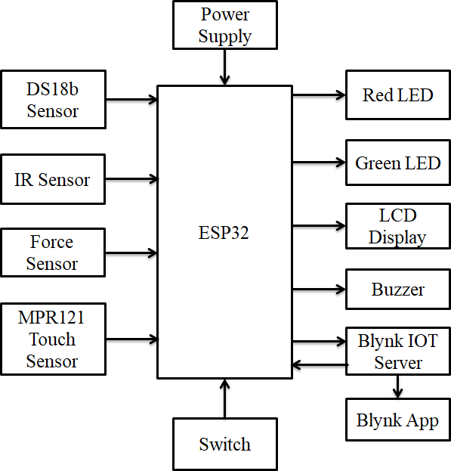

Fig 3.1: Block Diagram of the Smart yoga mat using IoT

- IR Sensor-Detects presence/movement of the body on the mat.
- DS18B20 Temp Sensor-Measures user’s body temperature during the session.
- Force Sensor-Detects body pressure/posture and presence on different mat zones.
- MPR121 Touch Sensor-Detects touch points or hand/feet placements during yoga poses.
- Green LED-Indicates correct posture or successful pose.

- Red LED-Warns of incorrect posture or alerts.
- LCD-Displays posture/temperature/feedback info on the mat.
- Buzzer-Gives audible feedback on pose errors or activity start/end.
- Switch-Turns system ON/OFF or starts the yoga session.
- Power Supply-Provides power to all connected components.
- ESP32-Central controller; reads sensors and sends data to the Blynk server.
- Blynk IoT Server-Receives sensor data and provides visualization through app.
- Blynk App (Mobile)-User interface for real-time monitoring and alerts.

SCHEMATIC DIAGRAM:

Core Controller: ESP32
- The ESP32 microcontroller acts as the brain.
- All sensors, LEDs, buzzer, LCD, and switch connect to ESP32 input/output (I/O) pins.
- It also connects to Wi-Fi for communication with Blynk IoT Server.

Sensors Connected to ESP32:
- IR Sensor-Output pin connected to a digital input pin of ESP32.
- DS18B20 Temp Sensor-Data pin connected to a digital input/output pin (OneWire). Pull-up resistor (~4.7kΩ) required.
- Force Sensor-Connected to an analog input (ADC) pin of ESP32.
- MPR121 Touch Sensor-Connected via I2C communication (SCL, SDA pins) to ESP32.

Output Devices Connected to ESP32:
- Green LED-Anode connected via resistor (~220Ω) to ESP32 digital output.
- Red LED-Same as Green LED but on a different digital output pin.
- Buzzer-Positive terminal connected via resistor to another output pin.
- LCD Display-Connected via I2C (shares same SCL, SDA lines with MPR121 or separate depending on address).
- Switch-Connected to a digital input with internal pull-up enabled.

Power Supply:
- Power Source: 5V regulated (from adapter or battery).
- ESP32 gets 3.3V internally.
- Sensors like DS18B20 and IR sensor use 3.3V or 5V depending on specifications.
- Common GND (ground) shared by all components.

Wireless Communication:
- ESP32 connects to Wi-Fi and sends data to the Blynk IoT server.

- Blynk App (on smartphone) communicates with the server to receive updates (e.g., posture alerts, temperature) and send commands (e.g., start session).
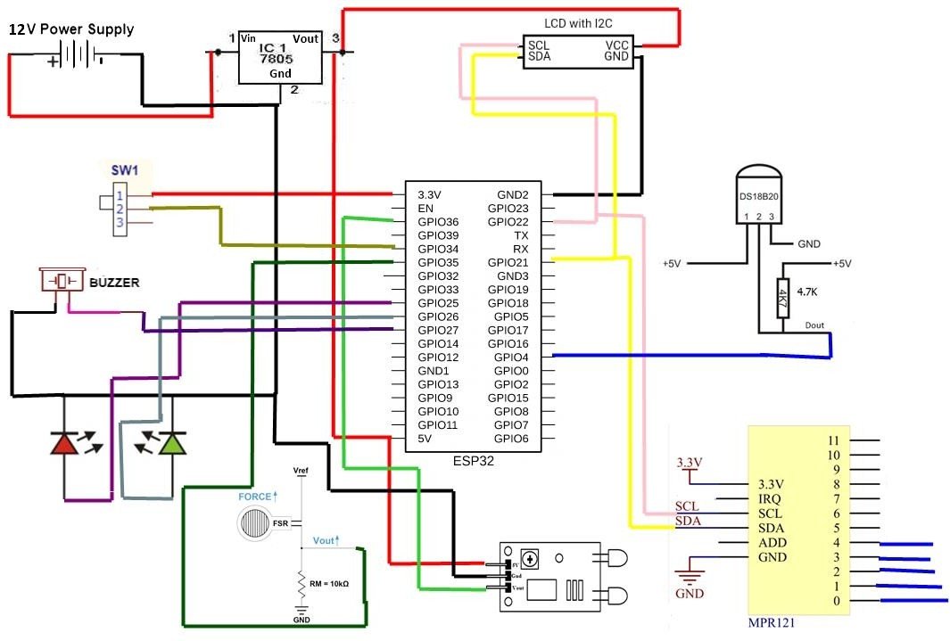
Fig 3.2: Schematic Diagram of Smart yoga mat using IoT

Logical Flow (Schematic in Words):
- Sensors → Sense body movement, force, touch, and temperature.
- ESP32 → Reads all sensors' data.
- Decision making:
- Good posture ➔ Turn ON Green LED.
- Bad posture ➔ Turn ON Red LED + Activate Buzzer.
- LCD → Displays status like ―Correct Pose‖ or temperature readings.
- Wi-Fi → ESP32 uploads sensor data to Blynk server.
- Blynk App → Shows live data, notifications, session control.

WORKING PRINCIPLE:
This project is a smart yoga mat that operates in two modes: Gym Mode and Yoga Mode. It monitors dips using an IR sensor, force applied with a force sensor, and temperature using a DS18B20 temperature sensor. The mat displays data on an I2C LCD, with LEDs and a buzzer providing alerts for high temperatures. The ESP32 microcontroller processes the sensor data and transmits it to a display or an IoT cloud for further analysis. The LCD display provides real-time feedback, guiding users toward better posture and alignment. Here’s a breakdown of the components, functionality, and how they work together.
- IR Sensor: Detects user movement and posture to count dips by analyzing infrared reflections, ensuring proper pose alignment.
- Force Sensor (FSR): Measures applied pressure at different points, helping users maintain balance and distribute weight evenly.
- DS18B20 Temperature Sensor: Monitors body heat fluctuations to analyze exertion levels and relaxation states.
- MPR121 touch Sensor: Identifies points of contact where hands and feet are placed, verifying correct positioning.
- Switch: Toggles between Gym Mode and Yoga Mode.
- I2C LCD Display: Displays the current mode, dips count or force reading, and temperature.
- Red and Green LEDs: Indicate temperature status. The red LED lights up if the temperature exceeds 38°C, while the green LED indicates normal temperature.
- Buzzer: Provides an audible alert when a high temperature is detected.
- Blynk IOT: Provides real-time feedback, stores user data, and offers insights on performance and posture corrections.
- Microcontroller: Processes sensor data and transmits it via Wi-Fi to the Blynk app.

FLOW CHART:

Start / Power On
  - Power is supplied via the Power Supply.
  - ESP32 initializes all components (sensors, LCD, LEDs, buzzer, Wi-Fi).

Wait for Start Command
  - Check if the Switch is pressed OR if a session is started via the Blynk App.
  - If not started, loop here.

Detect User Presence

  - IR Sensor and Force Sensor detect whether a user is on the mat.
  - If not present, wait.

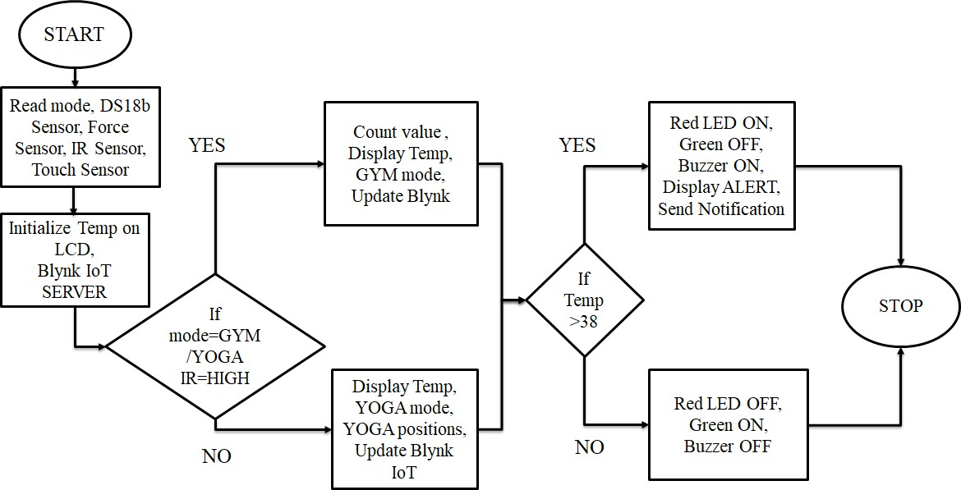

Fig 3.3: Flow Chart of Smart yoga mat using IoT

Monitor Sensors
  - Continuously:
    - Read MPR121 Touch Sensor (hand/foot placement).
    - Read Force Sensor (body pressure distribution).
    - Read DS18B20 Temperature Sensor (body temp).

Analyze Pose & Condition
  - Using logic:
    - If hand/foot placement and pressure match yoga pose → Correct.
    - Else → Incorrect.
    - Also check temperature for abnormal levels.

Provide Feedback

  - If pose is correct:
    - Turn ON Green LED
  - If pose is incorrect:
    - Turn ON Red LED
    - Activate Buzzer
    - Display status (pose result, temperature) on LCD.

Send Data to Cloud
  - ESP32 sends real-time data to Blynk IoT Server via Wi-Fi.
  - Blynk App displays:
    - Pose correctness
    - Temperature
    - Session time/status

Loop Until Session Ends
  - Keep monitoring until:
    - Switch is pressed again, OR
    - Session is ended via Blynk App

End Session
  - Turn OFF all indicators.
    - Display ―Session Ended‖ on LCD.
    - Go back to waiting for the next start command.

CHAPTER 4 HARDWARE DESCRIPTION

HARDWARE REQUIREMENTS:
- IR Sensor
- Force Sensor
- DS18b20 Sensor
- MPR121 Touch Sensor
- ESP32
- 16X2 LCD
- Adaptor/Power Supply
- Piezoelectric Buzzer
- LED
- Push button/Switch

IR SENSOR
An IR sensor is an electronic device that detects IR radiation falling on it. Proximity sensors (used in touchscreen phones and edge-avoiding robots), contrast sensors (used in line following robots), and obstruction counters/sensors (used for counting goods and in burglar alarms) are some applications involving IR sensors.

Purpose of IR Sensor
The IR sensor in a smart yoga mat serves several key purposes:
      - Posture Detection – Detects if the user is in the correct yoga pose by sensing body position.
      - User Presence Detection – Identifies if a person is on the mat using infrared waves.
      - Movement Tracking – Tracks motion to ensure correct yoga movements.
      - Temperature Monitoring – Some IR sensors can detect body temperature and surrounding conditions.
      - Gesture Control – Allows users to interact with the smart mat without physical touch.

IR Sensor Pin Configuration
A typical IR sensor module (like an IR proximity sensor) has three to four pins, including:

Table 4.1: Pin Configuration of IR sensor
Pin Name | Description
VCC | Power supply (3.3V – 5V)
GND | Ground connection
OUT | Digital output pin (High/Low signal based on detection)
EN (Optional) | Enable pin for turning the sensor ON/OFF
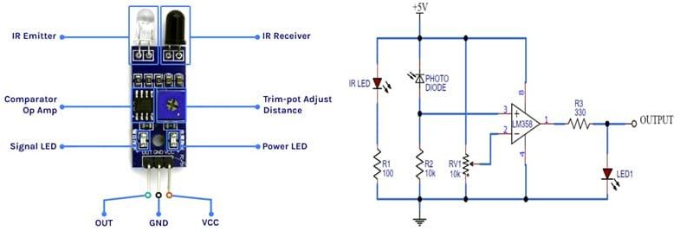
Fig 4.1: IR sensor with its Circuit Diagram

Working of IR Sensor
The IR sensor operates by emitting infrared rays and detecting the reflected signals from objects (such as the human body). The working principle is as follows:
      - Infrared Emission – The IR transmitter (LED) emits infrared light onto the yoga mat surface.
      - Reflection & Absorption – If a person is present, the IR rays are reflected back; otherwise, they are absorbed or dispersed.
      - Signal Processing – The IR receiver detects the reflected light and converts it into an electrical signal.
      - Microcontroller Processing – The signal is sent to a microcontroller (like Arduino, ESP32, or Raspberry Pi) for further analysis.
      - Data Transmission to IoT – The processed data is sent to a smartphone app or cloud server for real-time posture analysis and feedback.

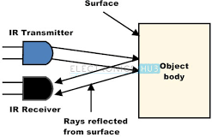

Fig 4.2: Working of IR sensor

Advantages of IR Sensor
      - Non-Contact Sensing – Detects user presence and movements without physical touch.
      - Fast Response Time – Provides real-time feedback on yoga poses.
      - Low Power Consumption – Consumes minimal energy, making it ideal for IoT applications.
      - Compact & Lightweight – Can be embedded into a thin yoga mat without affecting portability.
      - Affordable & Easy to Use – Cost-effective compared to high-end motion tracking systems.

Applications of IR Sensor
      - Posture Correction Systems – Alerts users if they are not in the correct pose.
      - Exercise Monitoring – Tracks movement patterns and duration of each yoga position.
      - Smart Fitness Integration – Connects with fitness apps for progress tracking and recommendations.
      - Gesture-Based Control – Enables users to interact with the mat without touching buttons.
      - Automated Feedback – Provides voice or haptic feedback for pose adjustments.

FORCE SENSOR
A square-shaped force sensor, also known as a Force-Sensitive Resistor (FSR), is a thin, flexible sensor that detects pressure and force changes. In a smart yoga mat, it plays a crucial role in posture detection, balance analysis, weight distribution monitoring, and real-time feedback for yoga practitioners. Square-shaped force sensors are usually made of a spring element, such as a metal beam, diaphragm, or cylinder, that is deformed when a force is applied to it. This Force Sensor has

a sensing area of 1.75 x 1.5″, sensing area and it will vary its resistance depending on how much pressure is being applied to the sensing area. The harder the force, the lower the resistance. When no pressure is being applied to the FSR its resistance will be larger than 1MΩ.This Pressure Sensor can sense force anywhere in the range of 100g-10kg and can be easily integrated with Microcontrollers, Arduino Boards, Raspberry Pi, etc. using Analog to Digital converters (ADC).
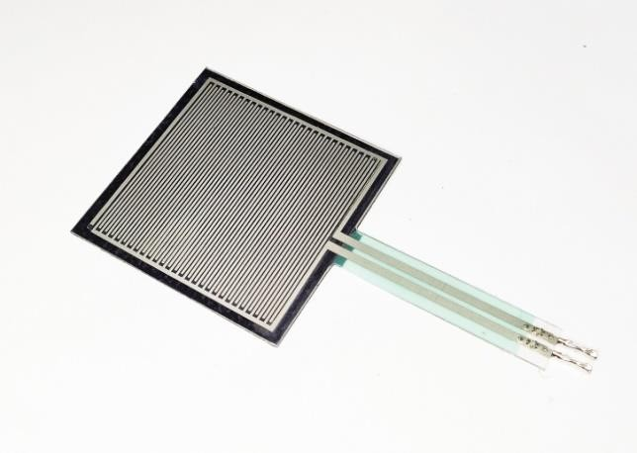
Fig 4.3: Force sensor

Purpose of Force Sensor

The force sensor in a smart yoga mat serves several important functions:

      - Posture Detection – Detects whether the user is placing their hands, feet, or body correctly.
      - Weight Distribution Analysis – Identifies if the user’s weight is evenly distributed in a yoga pose.
      - Balance Monitoring – Helps track stability and pressure shifts during yoga exercises.
      - Real-Time Feedback – Provides alerts (LED, buzzer, app notifications) for incorrect posture or uneven balance.
      - Pose Correction System – Works with IoT and AI to guide users toward correct form.
      - Workout Progress Tracking – Logs weight distribution data over time for personalized feedback.

Pin Configuration of Force Sensor
A square-shaped force sensor typically has two terminals:
Table 4.2: Pin Configuration of Force sensor
Pin | Description | ESP32/Arduino Pin
Terminal 1 | Connects to Analog Input  (ADC) via pull-down resistor. | GPIO 34 (for example)
Terminal 2 | Connects to VCC (3.3V or 5V). | 3.3V / 5V

Resistor Requirement: A 10kΩ pull-down resistor is needed to convert the variable resistance into a readable voltage signal

Working of Force Sensor

Step-by-Step Working Mechanism:
      - User Applies Pressure – When a user places hands, feet, or body on the mat, pressure is applied to the sensor.
      - Resistance Changes – The force sensor decreases its resistance as pressure increases.
      - ESP32 Reads Voltage – The voltage signal from the sensor is sent to an Analog-to-Digital Converter (ADC) pin on ESP32.
      - Force Calculation – ESP32 calculates the applied force using a pre-calibrated formula:
Force= Vout / Rpull-down
      - Data Processing & IoT Integration – The data is sent to an IoT platform (like Blynk or Google Firebase) for analysis.
      - Real-Time Feedback:
        - Correct Pressure & Balance → Green LED or Buzzer Beep
        - Incorrect Pressure Distribution → Red LED, Buzzer Alert, or Mobile Notification

Advantages of Force Sensor
      - Thin & Flexible – Easily embedded into a yoga mat without affecting comfort.
      - Highly Sensitive – Can detect even slight changes in force and pressure.
      - Low Power Consumption – Works efficiently with battery-powered IoT devices.
      - Easy Integration with IoT – Works well with ESP32, Arduino, and IoT platforms.
      - Durable & Long-Lasting – Designed to withstand repeated use in fitness applications.
      - Customizable Calibration – Can be adjusted for different weight levels and yoga styles.

Applications of Force Sensor
      - Posture Detection & Correction – Identifies incorrect poses and provides real-time feedback.
      - Weight & Pressure Distribution Monitoring – Helps users maintain even pressure across both feet and hands.
      - Balance Training & Stability Analysis – Useful for improving stability in complex yoga poses.
      - Smart Workout Tracking – Logs force data over time to track user progress and improvements.

      - IoT-Connected Health Monitoring – Data can be uploaded to a mobile app for real-time analysis and guidance.
      - AI-Based Yoga Coaching – Works with AI models to suggest pose adjustments based on pressure readings.

DS18B20 TEMPERATURE SENSOR
The DS18B20 is a digital temperature sensor widely used in IoT applications due to its high accuracy, waterproof capability, and one-wire communication. In a smart yoga mat, it helps track body temperature, mat surface temperature, and environmental conditions, enabling personalized yoga sessions and injury prevention.
This is a pre-wired and waterproofed version of the DS18B20 sensor. Handy for when you need to measure something far away, or in wet conditions. While the sensor is good up to 125°C the cable is jacketed in PVC so we suggest keeping it under 100°C. Because they are digital, you don't get any signal degradation even over long distances!
These 1-wire digital temperature sensors are fairly precise (±0.5°C over much of the range) and can give up to 12 bits of precision from the onboard digital-to-analog converter. They work great with any microcontroller using a single digital pin, and you can even connect multiple ones to the same pin, each one has a unique 64-bit ID burned in at the factory to differentiate them. Usable with 3.0-5.0V systems.
The only downside is they use the Dallas 1-Wire protocol, which is somewhat complex, and requires a bunch of code to parse out the communication. When using with microcontroller put a
4.7k resistor to sensing pin, which is required as a pullup from the DATA to VCC line.

Cable specs:

Stainless steel tube 6mm diameter by 30mm long
Cable is 36" long / 91cm, 4mm diameter (1 Meter Long) Contains DS18B20 temperature sensor
Three wires - Red connects to 3-5V, Black connects to ground and White is data. DS18B20 Sensor Technical specs:

Usable temperature range: -55 to 125°C (-67°F to +257°F) 9 to 12 bit selectable resolution
Uses 1-Wire interface- requires only one digital pin for communication

Unique 64 bit ID burned into chip Multiple sensors can share one pin
±0.5°C Accuracy from -10°C to +85°C Temperature-limit alarm system
Query time is less than 750ms Usable with 3.0V to 5.5V power/data

Purpose of DS18B20 Temperature Sensor
The DS18B20 sensor in a smart yoga mat serves multiple purposes:
      - Body Temperature Monitoring – Detects fluctuations in the user’s body temperature during workouts.
      - Heat Regulation Feedback – Measures mat surface temperature and adjusts smart heating elements (if present).
      - Injury Prevention – Alerts users if their body temperature rises too high, indicating overexertion.
      - Personalized Yoga Experience – Adapts workouts based on body temperature trends.
      - IoT Connectivity for Health Tracking – Sends data to a mobile app for long-term health monitoring and recommendations.

Pin Configuration of DS18B20 Temperature Sensor

The DS18B20 sensor has three pins:
Table 4.3: Pin Configuration of DS18B20 Temperature Sensor
Pin Name | Description
VCC | Power supply (3.3V – 5V)
GND | Ground connection
DQ (Data) | One-wire digital data communication pin

Wiring Options:
      - With pull-up resistor (4.7kΩ resistor between VCC and DQ) for stable data communication.
      - Multiple sensors can be connected on the same data line due to the one-wire protocol.

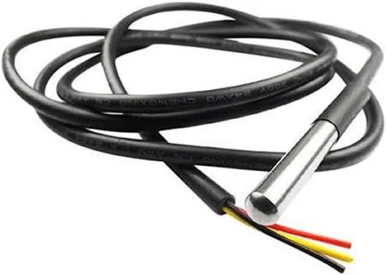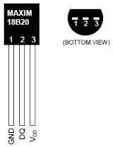
Fig 4.4: DS18B20 Temperature sensor

Working of DS18B20 Temperature Sensor
The DS18B20 operates using digital temperature sensing and the one-wire communication protocol:
      - Power Supply & Initialization – The microcontroller (ESP32, Arduino, or Raspberry Pi) initializes the DS18B20 sensor.
      - Temperature Measurement – The sensor measures temperature using an internal thermal sensor and converts it into digital data.
      - Data Communication via One-Wire Protocol – The sensor transmits temperature data through the DQ pin to the microcontroller.
      - Processing & IoT Connectivity – The microcontroller processes the temperature readings and sends them to an IoT cloud or mobile app.
      - User Feedback & Alerts – Based on temperature data, the yoga mat can:
        - Alert users if they overheat.
        - Adjust heating elements if the mat has temperature control features.
        - Personalize workouts based on body temperature trends.

Advantages of DS18B20 Temperature Sensor
      - High Accuracy – Measures temperature with an accuracy of ±0.5°C.
      - Wide Operating Range – Can measure from -55°C to +125°C, suitable for body and mat temperature detection.
      - One-Wire Communication – Reduces the number of wires needed, making it easy to integrate.

      - Waterproof Variants Available – Suitable for sweat-resistant applications.
      - Multiple Sensors on One Line – Allows tracking of temperature at different mat locations.
      - Low Power Consumption – Ideal for battery-powered IoT yoga mats.

Applications of DS18B20 Temperature Sensor
      - Body Temperature Monitoring – Detects real-time changes and alerts users if overheating occurs.
      - Mat Surface Temperature Control – Regulates heating elements in smart yoga mats with thermal regulation.
      - IoT Health Tracking – Sends temperature data to fitness apps for long-term analysis.
      - Personalized Yoga Workouts – Adjusts yoga routines based on individual temperature trends.
      - Smart Environment Adaptation – Can work with humidity and air quality sensors to optimize workout conditions.

MPR121 TOUCH SENSOR
The MPR121 is a capacitive touch sensor that detects touch and proximity using electrode pads. When integrated into a smart yoga mat, it enhances user interaction by enabling gesture-based control, pose detection, and automated feedback.

Purpose of MPR121 Touch Sensor
The MPR121 sensor is used in a smart yoga mat for:
      - Touch-Based Pose Detection – Identifies user contact points on the mat to analyze yoga poses.
      - Gesture Recognition – Allows users to interact with the mat using touch-based gestures.
      - Automated Feedback System – Alerts users if they are in an incorrect position based on touch points.
      - Multi-Touch Detection – Enables detection of multiple touch points for advanced pose tracking.
      - IoT Connectivity for Data Logging – Sends real-time touch data to a smartphone or cloud for analysis.

Pin Configuration of MPR121 Touch Sensor
The MPR121 sensor module typically has 12 touch channels and uses I2C communication.

Table 4.4: Pin Configuration of MPR121 Touch sensor
Pin Name | Description
VCC | Power supply (1.8V – 3.6V, typically 3.3V)
GND | Ground connection
SDA | I2C Data Line (Connects to microcontroller)
SCL | I2C Clock Line (Connects to microcontroller)
IRQ | Interrupt pin (Active when a touch is detected)
ADDR | Address selection pin for multiple sensors
ELE0–ELE11 | 12 Touch Electrodes for touch input
      - Multiple sensors can be connected to expand the number of touch points.
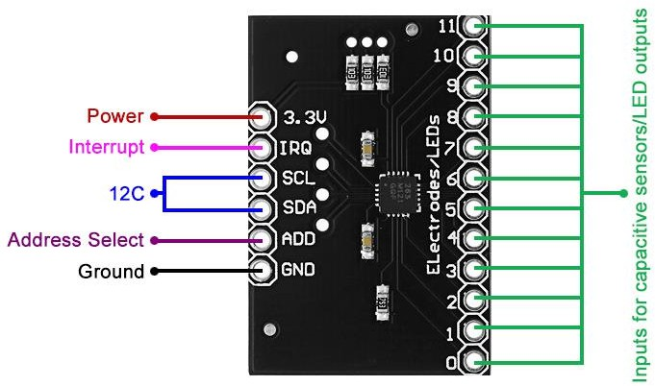

Fig 4.5: Pin Diagram of MPR121 Touch sensor

Working of MPR121 Touch Sensor
The MPR121 is a capacitive touch sensor that detects electrical changes when a user touches the mat. Here’s how it works:
      - Initialization & Power Supply – The sensor is powered (3.3V) and communicates with a microcontroller (ESP32, Raspberry Pi, or Arduino) via I2C protocol.
      - Electrode Sensing – The mat has capacitive electrodes embedded at key points.
      - Touch Detection – When a user touches the mat, a small change in capacitance is detected.
      - Signal Processing – The MPR121 processes the signal and sends data to the microcontroller.
      - IoT Data Transmission – The data is sent to a mobile app or cloud to analyze yoga postures and interactions.
      - Feedback Mechanism – The system provides real-time feedback (vibration, sound, or app notifications) if a pose is incorrect.

Advantages of MPR121 Touch Sensor
      - Multi-Touch Capability – Detects up to 12 independent touch points for enhanced yoga pose tracking.
      - High Sensitivity – Can detect light touches and hand/foot positions accurately.
      - Gesture-Based Control – Enables users to interact with the mat using simple touch gestures.
      - Fast Response Time – Provides real-time feedback for yoga postures.
      - Low Power Consumption – Ideal for battery-powered smart yoga mats.
      - Compact & Flexible – Can be integrated into thin yoga mats without affecting comfort.

Applications of MPR121 Touch Sensor
      - Yoga Pose Recognition – Identifies hand and foot positions on the mat for better posture analysis.
      - Gesture-Based Control – Allows users to control music, timers, or apps with touch gestures.
      - Real-Time Feedback – Sends vibration or sound alerts if incorrect poses are detected.
      - Smart Interaction – Integrates with IoT platforms for personalized yoga recommendations.
      - Multi-User Yoga Training – Tracks multiple users’ movements for group sessions.
      - Rehabilitation & Physiotherapy – Assists in post-injury recovery by tracking foot/hand placement.

ESP32
The ESP32 (CP2102, 30-Pin) is a powerful WiFi + Bluetooth development board widely used in IoT applications. When integrated into a smart yoga mat, it enables wireless data transmission, real-time posture analysis, and intelligent feedback via a mobile app or cloud server.
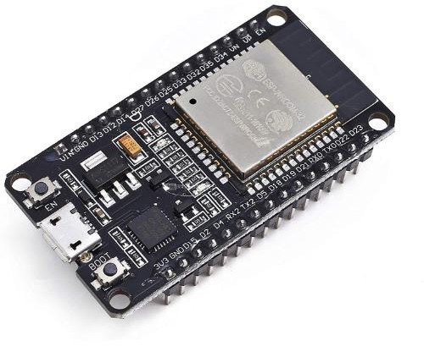

Fig 4.6: ESP32 (CP2102, 30-Pin) Development Board

Purpose of ESP32
ESP32 serves as the central processing and communication unit in a smart yoga mat, offering:
      - Wireless Connectivity – Enables WiFi & Bluetooth communication with mobile apps or cloud platforms.
      - Data Processing – Collects and processes data from force, temperature, and touch sensors.
      - Real-Time Feedback – Provides instant alerts or haptic feedback for incorrect yoga poses.
      - Power-Efficient Performance – Optimized for battery-powered smart devices.
      - IoT Cloud Integration – Transmits sensor data to a cloud server for AI-based posture correction.
      - Multi-Sensor Compatibility – Supports various sensors such as FSR (force sensors), DS18B20 (temperature sensors), and MPR121 (touch sensors).

Pin Configuration of ESP32

The ESP32 (CP2102, 30-Pin) development board has multiple GPIO pins, ADC, PWM, and communication interfaces.
Key Pin Configuration:
Table 4.5: Pin Configuration ESP32
Pin | Description
3V3 | 3.3V Power Output
GND | Ground
VIN | Power Input (5V)
GPIO2, GPIO4, GPIO12-19, GPIO21-23,  GPIO25-27, GPIO32-36 | General Purpose I/O (Used for sensors,  actuators)
TX (GPIO1), RX (GPIO3) | UART Communication
SDA (GPIO21), SCL (GPIO22) | I2C Interface for sensors (e.g., MPR121,  DS18B20)
SCK (GPIO18), MISO (GPIO19), MOSI  (GPIO23), CS (GPIO5) | SPI Interface
ADC (GPIO32-36) | Analog Inputs for force sensors
PWM (GPIO2, GPIO4, GPIO12-19) | Pulse Width Modulation (for haptic feedback,  buzzers, etc.)

      - CP2102 USB-to-Serial Driver – Allows easy programming and debugging via USB.

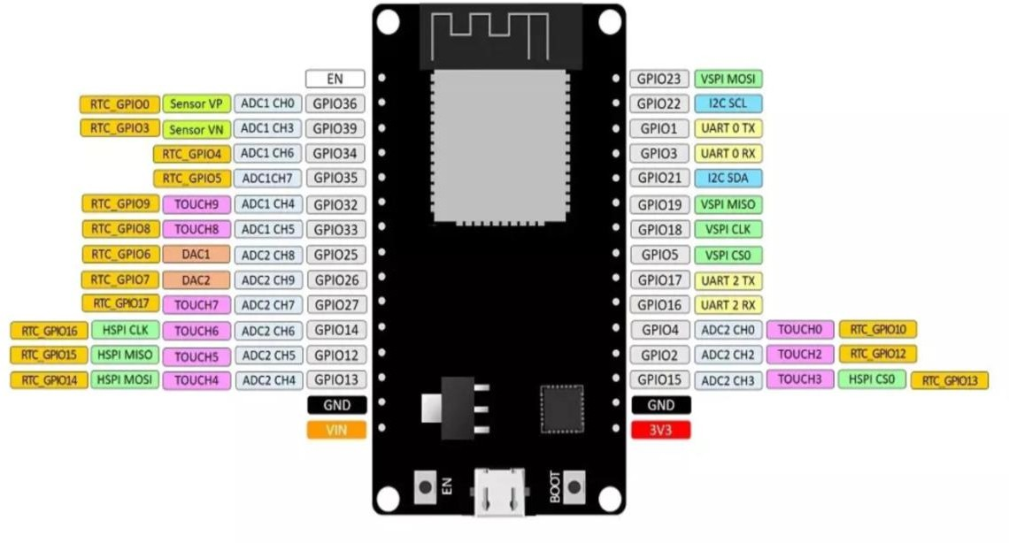

Fig 4.7: Pin Diagram of ESP32

Working of ESP32
The ESP32 acts as the brain of the smart yoga mat by reading sensor data, processing it, and wirelessly transmitting results to an IoT platform. The working mechanism is as follows:
      - Sensor Data Collection – The ESP32 receives inputs from:
        - Force Sensors (FSR) – Detects weight distribution.
        - Temperature Sensors (DS18B20) – Monitors body & mat temperature.
        - Touch Sensors (MPR121) – Identifies hand & foot positions.
      - Data Processing – The ESP32 analyzes the sensor data to determine posture accuracy.
      - Wireless Transmission – Sends data via WiFi (cloud) or Bluetooth (smartphone app) for feedback.
      - Real-Time Feedback – If an incorrect pose is detected, the ESP32 triggers:
        - Haptic feedback (vibration motor).
        - Sound alerts (buzzer).
        - Mobile notifications (via IoT app).
      - Cloud AI Processing (Optional) – Advanced systems use AI to analyze pose history and suggest improvements.

Advantages of ESP32
      - Dual Connectivity – WiFi & Bluetooth allow seamless data transmission.
      - High Processing Power – Handles real-time sensor data efficiently.
      - Multiple GPIOs – Supports various touch, force, and temperature sensors.
      - Low Power Consumption – Suitable for battery-powered yoga mats.
      - IoT Cloud Compatibility – Works with Google Firebase, AWS, MQTT, or Blynk.
      - OTA Updates – Supports over-the-air firmware updates.

Applications of ESP32
      - Posture Monitoring & Correction – Tracks yoga poses and provides feedback.
      - Gesture-Based Control – Enables touch & motion-based yoga session control.
      - IoT Health Tracking – Sends real-time data to a mobile app/cloud dashboard.
      - Temperature Regulation – Detects body heat and adjusts smart heating elements.
      - Smart Notifications & Alerts – Sends vibration or sound alerts for incorrect poses.
      - Multi-User Yoga Training – Can monitor multiple users in a group session.
      - Rehabilitation & Therapy – Tracks body balance and recovery progress.

16X2 LCD
The 16x2 LCD with I2C Interface is a widely used display module in IoT projects. When integrated into a smart yoga mat, it can display real-time feedback, pose correction tips, and health metrics without needing a smartphone or external screen.
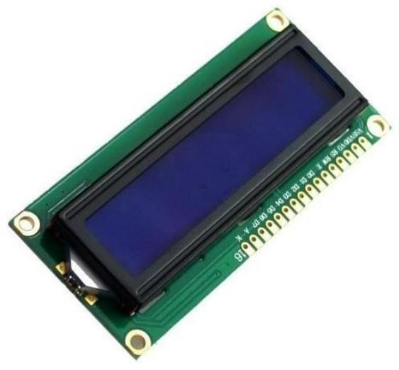
Fig 4.8: 16X2 LCD

Purpose of 16X2 LCD
The 16x2 LCD (16 characters × 2 lines) with I2C is used in a smart yoga mat to:
      - Provide Real-Time Feedback – Displays messages like "Correct your pose," "Relax your shoulders," or "Well done!".
      - Show Sensor Readings – Displays force, temperature, or touch sensor values.
      - Indicate Workout Progress – Shows pose completion percentage, session time, or reps.
      - Work Without a Smartphone – Users can check feedback without needing a mobile app.
      - Reduce Power Consumption – A low-energy alternative to OLED or TFT displays.
      - Improve Accessibility – Helps users who may not want to check an app while doing yoga.

Pin Configuration of 16X2 LCD
A 16x2 LCD typically requires multiple GPIO pins, but the I2C version reduces this to just two pins:
Table 4.6: Pin Configuration of 16X2 LCD
LCD Pin | Description | I2C Pin (PCF8574 Chip)
VCC | Power supply (5V) | VCC
GND | Ground | GND
SDA | I2C Data Line | GPIO21 (ESP32)
SCL | I2C Clock Line | GPIO22 (ESP32)

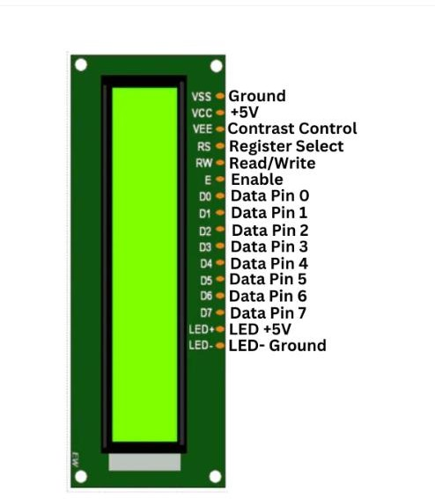

Fig 4.9: Pin Diagram of 16X2 LCD

Working of 16X2 LCD

Step-by-Step Working Mechanism
      - Power & Initialization – The LCD receives 5V power from ESP32.
      - I2C Communication – The ESP32 communicates with the LCD via SDA (GPIO21) and SCL (GPIO22).
      - Data Processing – The ESP32 processes sensor data from:
        - Force Sensors (FSR) – Detects pressure & weight distribution.
        - Touch Sensors (MPR121) – Identifies hand & foot placement.
        - Temperature Sensors (DS18B20) – Measures mat & body temperature.
      - Displaying Information – The LCD updates every few seconds to show real-time feedback.
      - User Interaction & Alerts – The LCD displays messages like:
        - "Hold this pose for 10 seconds."
        - "Increase balance on left foot."
        - "Mat temperature: 28°C."
      - Custom Messages & IoT Integration – The LCD can display motivational messages from an IoT cloud.

Advantages of 16X2 LCD
      - Low Power Consumption – Uses less energy than OLED or TFT displays.
      - I2C Reduces Wiring Complexity – Only two GPIO pins needed for communication.
      - Real-Time Updates – Displays sensor readings instantly.
      - Offline Functionality – Works without internet or a smartphone.
      - Affordable & Readable – Cost-effective and visible even in daylight.

Applications of 16X2 LCD
      - Pose Correction Feedback – Displays real-time posture improvements.
      - Workout Timer & Progress – Shows time left for a pose or session completion.
      - Smart Coaching Without a Phone – Eliminates the need for checking a mobile screen.
      - Customized Yoga Sessions – Displays custom workout instructions from an IoT app.

POWER SUPPLY
The power supply or adaptor is a crucial component in a smart yoga mat as it ensures a stable

and efficient power source for all sensors, microcontrollers (ESP32, Arduino), displays (LCD, OLED), and actuators (vibration motors, buzzers, heating elements).

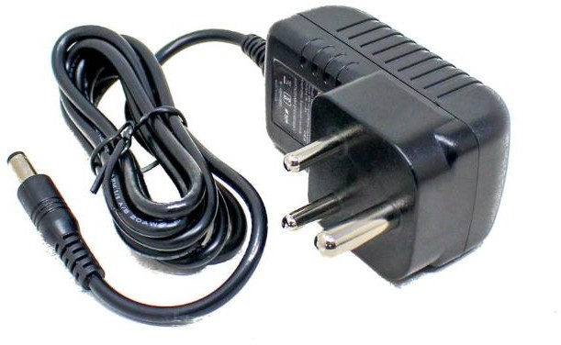
Fig 4.10: Power supply

Purpose of Power Supply
A smart yoga mat requires a reliable power source to ensure uninterrupted functionality of all connected components. The power supply is responsible for:
      - Providing Stable Power – Delivers constant 5V or 3.3V to sensors and controllers.
      - Ensuring Efficient Energy Usage – Prevents voltage fluctuations and overheating.
      - Powering IoT Connectivity – Enables WiFi & Bluetooth functions for cloud communication.
      - Supporting Actuators & Feedback Mechanisms – Provides power for vibration motors, buzzers, heating elements, and displays.
      - Battery or Wired Power Management – Supports portable battery operation or plug-in adaptors for continuous use.

Pin Configuration of Power Supply
The power source can be either a DC adaptor (plug-in power) or a rechargeable battery.

DC Adaptor (Plug-In Power Supply)
Table 4.7: Pin Configuration of DC Adaptor
Adaptor Output | Description
5V Output | Powers ESP32, sensors, and actuators.
9V/12V Output | Used for heating elements or high-power  components.
2A/3A Current Rating | Ensures sufficient current for multiple  components.
DC Barrel Jack or USB Input | Connects to a power socket.

Battery-Based Power Supply
Table 4.8: Pin Configuration of Battery-Based Power supply
Battery Type | Voltage & Current | Usage
Lithium-Ion (Li-Ion) 18650 | 3.7V, 2000-3000mAh | Portable power option
Lithium Polymer (Li-Po) | 3.7V, 500-10000mAh | Lightweight and compact
Power Bank | 5V, 2A | Convenient and rechargeable

      - Voltage Regulators (e.g., AMS1117 3.3V) are used to step down voltage from 5V to 3.3V for ESP32.

Working of Power Supply
      - Power Source Selection – The mat can be powered by a DC adaptor (wall socket) or a battery pack.
      - Voltage Regulation – If using a higher voltage source (9V or 12V), a voltage regulator steps down the voltage to 5V or 3.3V.
      - Power Distribution – The ESP32 and sensors receive 3.3V, while LCD, actuators, and heating elements get 5V or 12V as needed.
      - IoT Functionality – The ESP32 remains connected to WiFi/Bluetooth without interruptions.
      - Battery Management (if applicable) – If running on battery, a charging module (TP4056 for Li- Ion) ensures safe recharging.
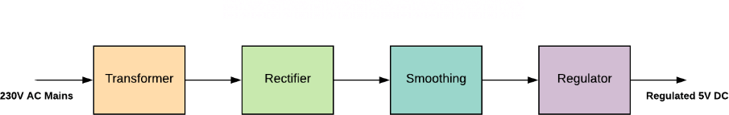

Fig 4.11: Flow Diagram of Power supply

Advantages of Power Supply
      - Stable & Reliable Power – Prevents device malfunctions due to voltage fluctuations.
      - Supports Multiple Components – Provides sufficient current for ESP32, sensors, displays, actuators.
      - Portable & Wireless Option – Rechargeable batteries allow cord-free operation.
      - Prevents Overheating & Damage – Proper power management protects sensitive components.

Applications of Power Supply
      - Wireless Smart Yoga Mats – Uses battery packs for completely wireless operation.
      - Heated Yoga Mats – Provides 12V power for heating elements.
      - Real-Time Feedback Systems – Ensures LCD/OLED displays, vibration motors, and sensors function properly.
      - IoT-Connected Mats – Keeps WiFi/Bluetooth active for mobile app integration.
      - Fitness Tracking & Health Monitoring – Powers sensors for posture tracking & biometric analysis.

PIEZOELECTRIC BUZZER
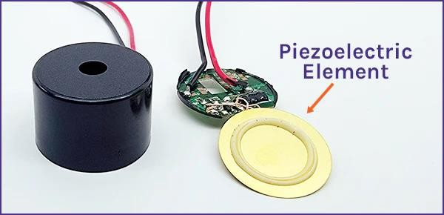
A piezoelectric buzzer is a compact sound-generating device that converts electrical signals into audible tones. In a smart yoga mat, it is used to provide audio feedback, alerts for incorrect postures, breathing guidance, and session notifications without needing a visual display or mobile phone.

Fig 4.12: Piezoelectric buzzer

Purpose of Piezoelectric Buzzer
The piezo buzzer in a smart yoga mat serves the following purposes:
      - Real-Time Audio Feedback – Provides beep sounds to indicate correct or incorrect poses.
      - Session Start & End Alerts – Notifies users when a yoga session starts, ends, or moves to the next pose.
      - Breathing & Meditation Guidance – Generates rhythmic beeps for inhale/exhale synchronization.
      - Posture Correction Notifications – Alerts users if their balance, force, or alignment is incorrect.
      - Low Power Consumption – Uses minimal power, making it ideal for battery-operated yoga mats.
      - Hands-Free Experience – Eliminates the need to constantly check a mobile screen.

Pin Configuration of Piezoelectric Buzzer
A piezo buzzer usually has two pins:

Table 4.9: Pin Configuration of Piezoelectric buzzer
Pin | Description | ESP32/Arduino Pin
Positive (+) | Connects to the PWM output  pin of ESP32 or Arduino. | GPIO25 (or any PWM-  capable pin)
Negative (-) | Connects to GND (Ground). | GND

      - Some buzzers also have a built-in transistor driver, allowing direct connection to 3.3V or 5V sources.
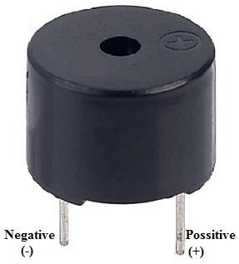

Fig 4.13: Pin Diagram of Piezoelectric buzzer

Working of Piezoelectric Buzzer Step-by-Step Working Mechanism
      - Sensor Data Processing – The ESP32 collects data from sensors:
- Force Sensors (FSR) – Detect pressure and weight distribution.
- Touch Sensors (MPR121) – Identify user hand and foot placement.
- Temperature Sensors (DS18B20) – Monitor mat and body temperature.
      - Pose Analysis & Feedback – The ESP32 analyzes sensor data to determine posture correctness.
      - Generating Sound Alerts – Based on conditions, the buzzer produces different tones & patterns:
- Short Beep – Pose correction required.
- Long Beep – Session completed.
- Rhythmic Beeps – Breathing synchronization (inhale/exhale guidance).
      - IoT Integration – The buzzer can be triggered remotely via Blynk or a mobile app.

Advantages of Piezoelectric Buzzer
      - Low Power Consumption – Ideal for battery-operated yoga mats.
      - Compact & Lightweight – Easily embedded into the mat without increasing bulk.
      - Immediate Audio Feedback – Provides real-time alerts without visual distractions.
      - Simple & Cost-Effective – Requires only two connections and minimal code.
      - Hands-Free Interaction – Users don’t need to look at a display or smartphone.

Applications of Piezoelectric Buzzer
      - Yoga Pose Correction Alerts – Beeps when users need to adjust their posture.
      - Breathing & Meditation Guidance – Rhythmic beeps help with inhale/exhale synchronization.
      - Workout Timer & Session Alerts – Notifies users when a pose starts, ends, or transitions.
      - Low Battery & System Warnings – Audio alerts for low battery or sensor malfunctions.
      - Interactive Training Assistance – Can work with AI for real-time coaching feedback.

LED
LED indicators (Green & Red) play a crucial role in providing visual feedback in a smart yoga mat. These LEDs can be used to indicate correct and incorrect postures, session status, breathing patterns, and notifications without needing a smartphone or display. Red LEDs are typically made from Aluminum Gallium Arsenide (AlGaAs) or Aluminum Indium Gallium Phosphide (AlInGaP) semiconductor materials. Green LEDs are typically made using aluminum gallium phosphide (AlGaP) or indium gallium nitride (InGaN) semiconductor materials.
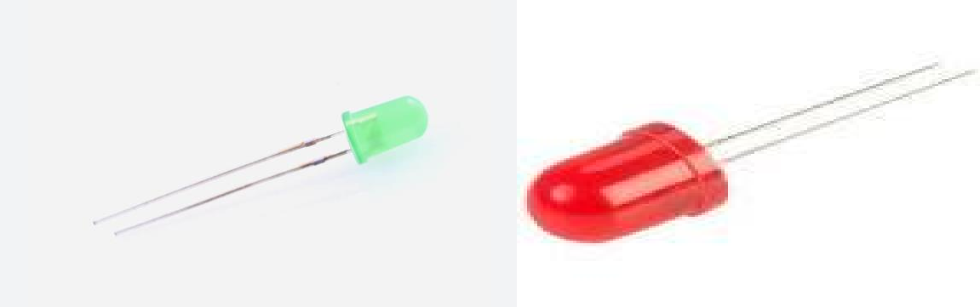
Fig 4.14: Green LED and Red LED

Purpose of Green LED and Red LED
The Green and Red LEDs in a smart yoga mat serve the following purposes:

      - Pose Correction Feedback – Green LED lights up when the pose is correct, and Red LED when incorrect.
      - Session Status Indicator – Green for "active session", Red for "paused" or "stopped".
      - Breathing & Meditation Guidance – Blinking patterns guide inhale (Green) and exhale (Red).
      - Force & Balance Indication – Shows if body weight is evenly distributed (Green) or imbalanced (Red).
      - Low Battery Warning – Red LED indicates low power.
      - IoT Connectivity Alerts – Green means connected, Red means disconnected.

Pin Configuration of Green LED and Red LED
A standard LED module consists of two pins (Anode & Cathode).

Table 4.10: Pin Configuration of Green LED and Red LED
Pin | Description | ESP32
Anode (+) | Connects to ESP32 output pin (via  a resistor). | GPIO 5 (Green), GPIO 18  (Red)
Cathode (-) | Connects to GND (Ground). | GND
      - Resistor (220Ω to 1kΩ) is required to limit current flow and prevent LED damage.

Working of Green LED and Red LED Step-by-Step Working Mechanism
      - Sensor Data Processing – ESP32 collects data from:
        - Force Sensors (FSR) – Detects balance & pressure.
        - Touch Sensors (MPR121) – Identifies hand & foot positions.
        - Temperature Sensors (DS18B20) – Measures mat temperature.
      - Pose Analysis – The ESP32 checks if the posture is correct using predefined values.
      - LED Feedback:
        - Green LED ON → Correct Pose, Balanced Weight, or Successful IoT Connection.
        - Red LED ON → Incorrect Pose, Imbalance, or Disconnection.
      - Breathing Pattern Indication –
        - Green LED pulses for inhale, Red LED pulses for exhale.
      - Power & Connectivity Alerts – Red LED blinks for low battery or WiFi disconnection.

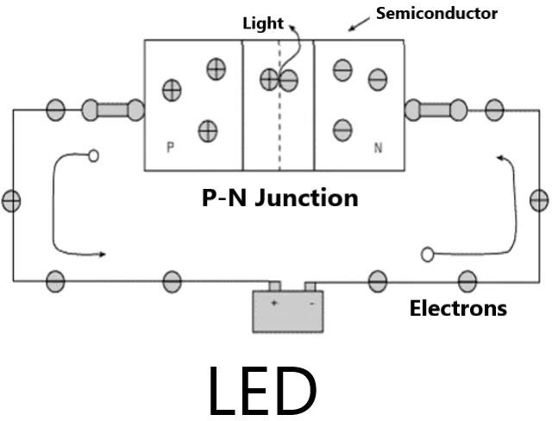

Fig 4.15: Working of LED

Advantages of Green LED and Red LED
      - Instant Visual Feedback – Users get immediate posture correction.
      - Low Power Consumption – LEDs use minimal power, ideal for battery-operated mats.
      - Simple & Cost-Effective – Requires only two GPIO pins and resistors.
      - Enhances Hands-Free Interaction – No need to check a phone screen.
      - Works Offline – Provides feedback without requiring an internet connection.

Applications of Green LED and Red LED
      - Posture Correction System – Green LED confirms correct poses, Red LED warns of incorrect alignment.
      - Balance & Weight Distribution Alerts – Shows even weight (Green) or imbalance (Red).
      - Session Start & Stop Indicators – Green for "Active", Red for "Paused" or "Stopped".
      - Breathing Exercise Assistant – Green for inhale, Red for exhale timing.
      - IoT & Connectivity Status – Green for connected, Red for disconnected.
      - Low Battery & System Warnings – Red LED flashes when power is low.

PUSH BUTTON
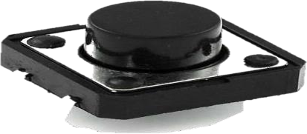
Fig 4.16: Push button

A pushbutton or switch in a smart yoga mat allows users to interact with the system manually. It can be used to turn the mat ON/OFF, change workout modes, start/stop yoga sessions, reset the system, or activate special functions like voice guidance or feedback control.

Purpose of Push button
A pushbutton or switch in a smart yoga mat serves several important functions:
      - Power ON/OFF Control – Allows users to turn the smart mat on or off without unplugging it.
      - Session Start/Stop Control – Enables users to start or pause a yoga session.
      - Workout Mode Selection – Users can switch between different yoga programs or intensity levels.
      - Posture Correction Reset – A button press can reset or recalibrate the posture detection system.
      - Manual Feedback Control – Users can manually confirm posture correctness when sensors are ambiguous.
      - Emergency Stop – In case of discomfort or incorrect posture, users can quickly stop feedback mechanisms.

Pin Configuration Push button
A pushbutton usually has four terminals, but in most cases, we use only two pins:

Table 4.11: Pin Configuration Push button
Pin | Description | ESP32/Arduino Pin
NO (Normally Open) | Connected to GPIO input. | GPIO 12 (for example)
COM (Common) | Connected to GND. | GND

Working of Push button
Step-by-Step Working Mechanism
      - User Presses the Button – This sends a LOW or HIGH signal to ESP32.
      - ESP32 Reads Button Input – The system detects a state change from LOW to HIGH (pressed).
      - Action is Triggered – Based on the button function, the ESP32 performs an action:
        - Session Start/Stop – A single press starts or pauses the yoga session.
        - Mode Switching – Long press changes the workout mode.
        - Feedback Reset – Pressing resets any incorrect posture warnings.
        - Power ON/OFF – If a toggle switch is used, it powers the system.

      - Debouncing Mechanism – A software debounce is used to filter accidental multiple presses.

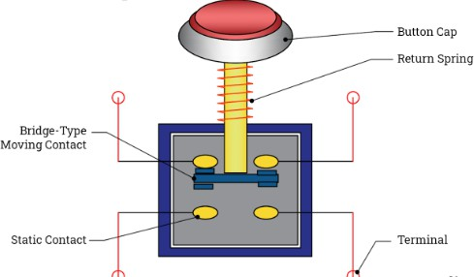
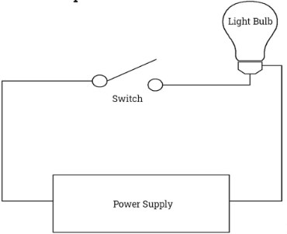

Fig 4.17: Working of Push button

Advantages of Push button
      - Simple & Intuitive – Users can easily control the mat without a mobile app.
      - Reliable & Instant Response – Works without delays, unlike touchscreen interfaces.
      - Low Power Consumption – Uses minimal power, making it ideal for battery-powered mats.
      - Works Without Internet – Unlike IoT-based control, buttons work offline.
      - Cost-Effective & Durable – Requires minimal components and lasts a long time.

Applications of Push button
      - Yoga Session Control – Start, stop, or pause sessions manually.
      - Mode Selection – Change between different yoga routines or intensity levels.
      - Posture Reset Button – Users can reset posture feedback in case of misinterpretation.
      - Power ON/OFF Switch – Turns the smart mat ON or OFF.
      - Emergency Stop – Instantly stops feedback mechanisms in case of discomfort.
      - IoT Connectivity Reset – Can be used to reset WiFi or Bluetooth connections.

CHAPTER 5

SOFTWARE DESCRIPTION

CREATING PROJECT IN ARDUINO 1.7.11 VERSION

ARDUINO IDE INSTALLATION:
In this we will get know of the process of installation of Arduino IDE and connecting Arduino uno to Arduino IDE.
STEP 1: First we must have our Arduino board (we can choose our favorite board) and a USB cable. In case we use Adriana UNO, Arduino Duemilanove, Nano, Arduino Mega 2560, or Diecimila, we will need a standard USB cable (A plug to B plug), t In case we use Arduino Nano, we will need an A to Mini-B cable.
STEP 2: Download Arduino IDE Software. We can get different versions of Arduino IDE from the Download page on the Arduino Official website. We must select wer software, which is compatible with wer operating system (Windows, IOS, or Linux).
After wear file download is complete, unzip the file.
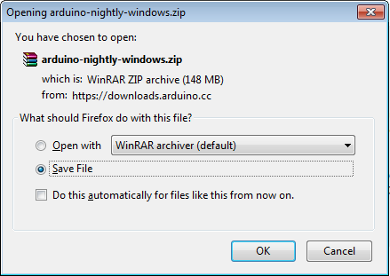
Fig 5.1: Downloading Arduino IDE software
STEP 3: Power up our board.
The Arduino Uno, Mega, Duemilanove and Arduino Nano automatically draw power from either, the USB connection to the computer or an external power supply. If we are using an Arduino Diecimila, we have to make sure that the board is conFigd to draw power from the USB connection. The power source is selected with a jumper, a small piece of plastic that fits onto two of the three pins between the USB and power jacks.
Check that it is on the two pins closest to the USB port.
Connect the Arduino board to wer computer using the USB cable. The green power LED

(labeled PWR) should glow.
STEP 4: Launch Arduino IDE.
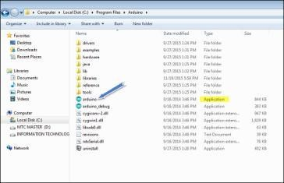
Fig 5.2: Launching Arduino IDE
After our Arduino IDE software is downloaded, we need to unzip the folder. Inside the folder, we can find the application icon with an infinity label (application.exe).
Double click the icon to start the IDE.
STEP 5: Open our first project.
Once the software starts, we have two options
- Create a new project
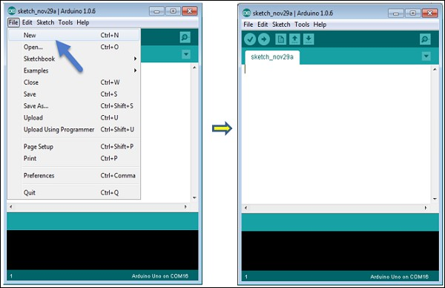
Fig 5.3: Creating new project
- Open an existing project example.
To create a new project, select File → New.
To open an existing project example, select File → Example → Basics → Blink.
Here, we are selecting just one of the examples with the name Blink. It turns the LED on and off

with some time delay. We can select any other example from the list.
STEP 6: Select our Arduino board.
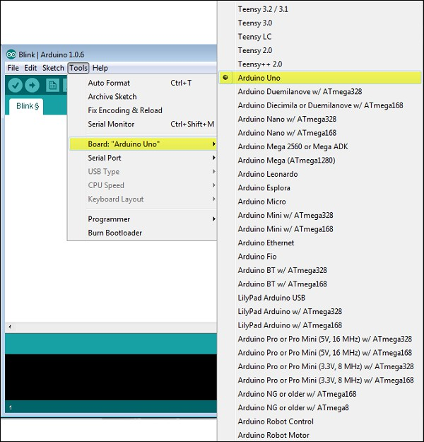
Fig 5.4: Selecting Arduino board
To avoid any error while uploading wear program to the board, we must select the correct Arduino board name, which matches with the board connected to wer computer.
Go to Tools → Board and select wear board.
Here, we have selected Arduino Uno board according to our tutorial, but we must select the name matching the board that we are using.
STEP 7: Select wer serial port.

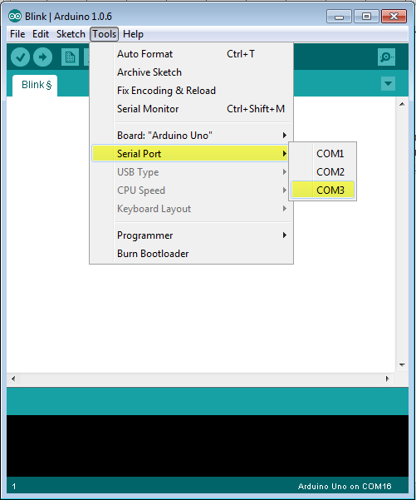
Fig 5.5: Selecting serial port

Select the serial device of the Arduino board. Go to Tools → Serial Port menu. This is likely to be COM3 or higher (COM1 and COM2 are usually reserved for hardware serial ports). To find out, we can disconnect wer Arduino board and re-open the menu, the entry that disappears should be of the Arduino board. Reconnect the board and select that serial port.
STEP 8: Upload the program to wer board.
Before explaining how we can upload our program to the board, we must demonstrate the function of each symbol appearing in the Arduino IDE toolbar.

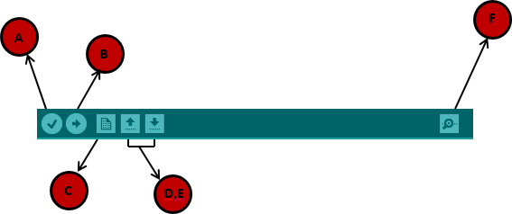

Fig 5.6: Arduino IDE toolbar

A − Used to check if there is any compilation error.
B − Used to upload a program to the Arduino board.
C − Shortcut used to create a new sketch.
D − Used to directly open one of the example sketch.
E − Used to save wer sketch.
F − Serial monitor used to receive serial data from the board and send the serial data to the board. Now, simply click the "Upload" button in the environment. Wait a few seconds; we will see the RX and TX LEDs on the board, flashing. If the upload is successful, the message
"Done uploading" will appear in the status bar.
Note − If we have an Arduino Mini, NG, or other board, we need to press the reset button physically on the board, immediately before clicking the upload button on the Arduino Software.

BLYNK APP
Blynk was designed for the Internet of Things. It can control hardware remotely, it can display sensor data, it can store data, vizualize it and do many other cool things.
There are three major components in the platform:
- Blynk App - allows to you create amazing interfaces for your projects using various widgets we provide.
- Blynk Server - responsible for all the communications between the smartphone and hardware. You can use our Blynk Cloud or run your private Blynk server locally. It’s open- source, could easily handle thousands of devices and can even be launched on a Raspberry Pi.
- Blynk Libraries - for all the popular hardware platforms - enable communication with the

server and process all the incoming and outcoming commands.
Now imagine: every time you press a Button in the Blynk app, the message travels to space the Blynk Cloud, where it magically finds its way to your hardware. It works the same in the opposite direction and everything happens in a blynk of an eye.
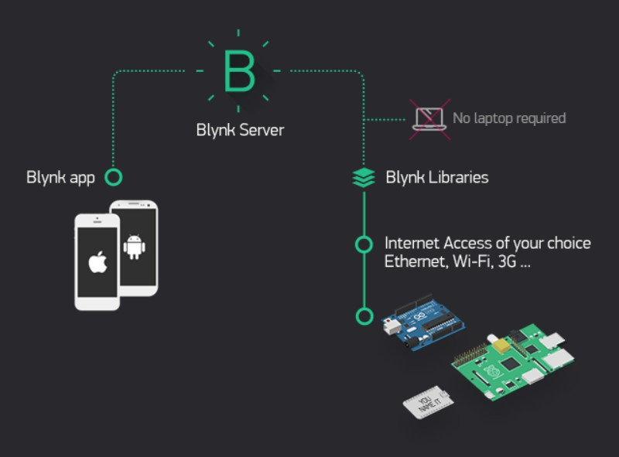
Fig 5.7: Connectivity of Blynk

- Similar API & UI for all supported hardware & devices
- Connection to the cloud using:
  - WiFi
  - Bluetooth and BLE
  - Ethernet
  - USB (Serial)
  - GSM
- Set of easy-to-use Widgets
- Direct pin manipulation with no code writing
- Easy to integrate and add new functionality using virtual pins
- History data monitoring via Super Chart widget
- Device-to-Device communication using Bridge Widget
- Sending emails, tweets, push notifications, etc.
- New features are constantly added!

You can find example sketches covering basic Blynk Features. They are included in the library. All the sketches are designed to be easily combined with each other.

The Blynk App is a well designed interface builder. It works on both iOS and Android, so no holywars here,
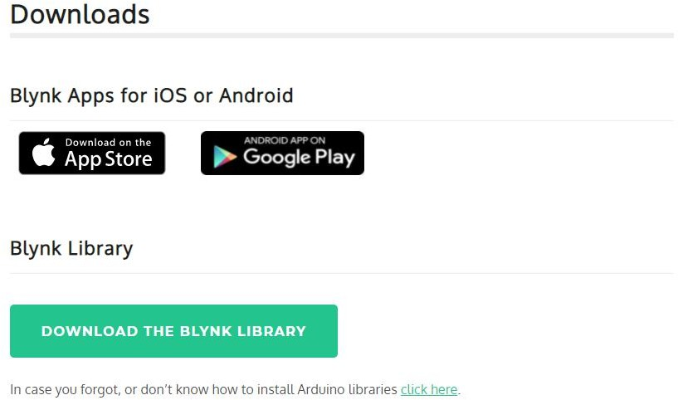

Fig 5.8: Downloads of Blynk

CREATE A BLYNK ACCOUNT
After you download the Blynk App, you’ll need to create a New Blynk account. This account is separate from the accounts used for the Blynk Forums, in case you already have one. We recommend using a real email address because it will simplify things later.
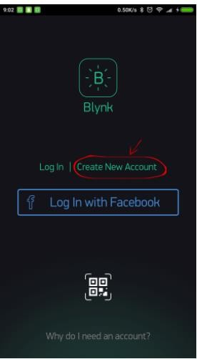
Fig 5.9: Create a Blynk account

CREATE A NEW PROJECT
After you’ve successfully logged into your account, start by creating a new project.

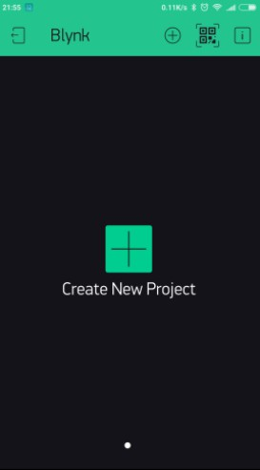
Fig 5.10: Create a new project

CHOOSE YOUR HARDWARE
Select the hardware model you will use. Check out the list of supported hardware
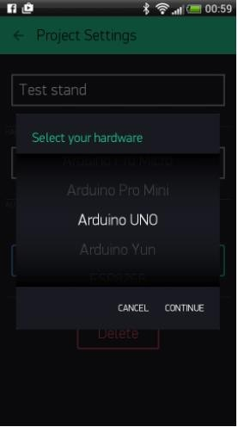
Fig 5.11: Choosing hardware

AUTH TOKEN
Auth Token is a unique identifier which is needed to connect your hardware to your smartphone. Every new project you create will have its own Auth Token. You’ll get Auth Token automatically on your email after project creation. You can also copy it manually. Click on devices section and selected required device:
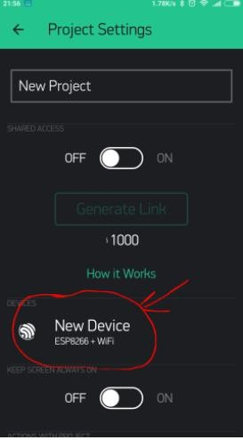
Fig 5.12: Connect to hardware

NOTE: Don’t share your Auth Token with anyone, unless you want someone to have access to your hardware.
It’s very convenient to send it over e-mail. Press the e-mail button and the token will be sent to the e-mail address you used for registration. You can also tap on the Token line and it will be copied to the clipboard.
Now press the “Create” button.

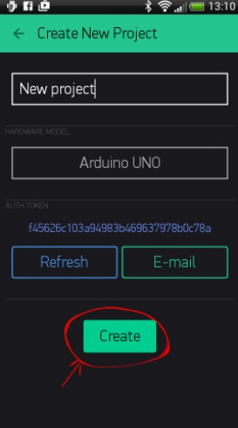
Fig 5.13: Create new project

ADD A WIDGET
Your project canvas is empty, let’s add a button to control our LED.
Tap anywhere on the canvas to open the widget box. All the available widgets are located here. Now pick a button.
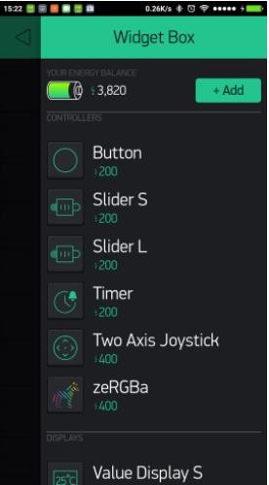
Fig 5.14: Widget box

Drag-n-Drop - Tap and hold the Widget to drag it to the new position.

Widget Settings - Each Widget has it’s own settings. Tap on the widget to get to them.

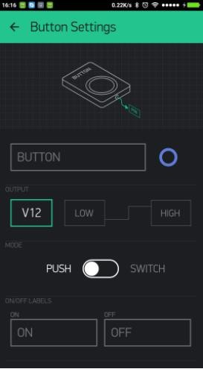
Fig 5.15: Button settings

The most important parameter to set is PIN. The list of pins reflects physical pins defined by your hardware. If your LED is connected to Digital Pin 8 - then select D8 (D - stands for Digital).

RUN THE PROJECT
When you are done with the Settings - press the PLAY button. This will switch you from EDIT mode to PLAY mode where you can interact with the hardware. While in PLAY mode, you won’t be able to drag or set up new widgets, press STOP and get back to EDIT mode.
You will get a message saying ―Arduino UNO is offline‖. We’ll deal with that in the next section

RESULT:

CHAPTER 6 RESULT

Overall System Behavior:
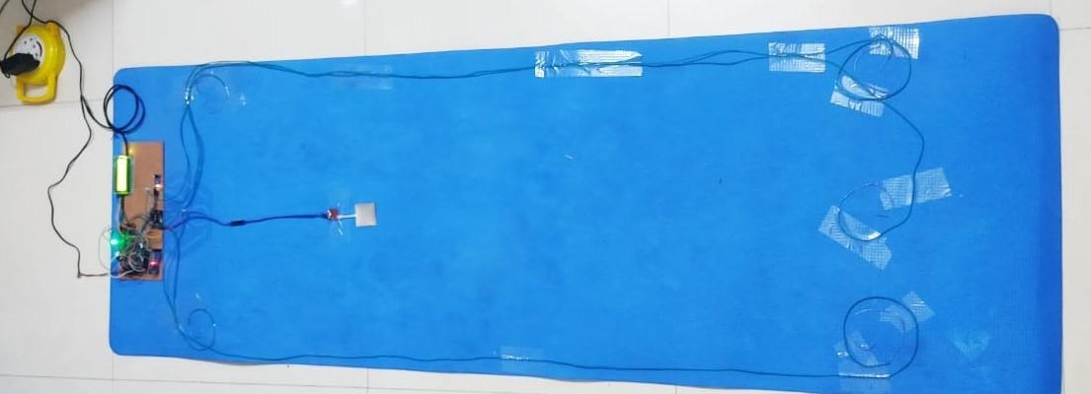
After assembling and programming the system, the Smart Yoga Mat successfully monitors the user’s presence, posture, body temperature, and touch/pressure points during a yoga session. It provides instant feedback through LEDs, buzzer, and LCD, and shares real-time session data to the Blynk App via the IoT server.
Fig 6.1: Smart yoga mat

Detailed Results by Component:
    - IR Sensor-Accurately detects the user's presence on the mat when they step on it.
    - Force Sensor-Measures pressure points correctly, helping assess body posture and weight distribution.
    - DS18B20 Temperature Sensor-Continuously monitors and displays the user's body temperature during exercise.
    - Green LED-Lights up when the correct posture is detected.
    - Red LED-Turns ON if an incorrect posture is detected or if a warning condition occurs.
    - Buzzer-Sounds an alert when there is a wrong pose or temperature out of range.
    - LCD-Displays real-time updates like posture status ("Correct Pose" / "Incorrect Pose") and temperature values.
    - Switch-Allows the user to easily start and stop yoga sessions manually.
    - ESP32-Manages all sensor readings, controls outputs, connects to Wi-Fi, and sends data to the Blynk IoT server.
    - Power Supply-Provides stable power to all modules ensuring reliable performance.
    - Blynk IoT Server-Receives and stores session data from ESP32 for monitoring and analysis.
    - Blynk App-Displays session details live, including temperature, posture correctness, and session

timer. Sends alerts for errors or achievements.
    - MPR121 Touch Sensor-Successfully detects multiple touch points (hands/feet) for different yoga poses.
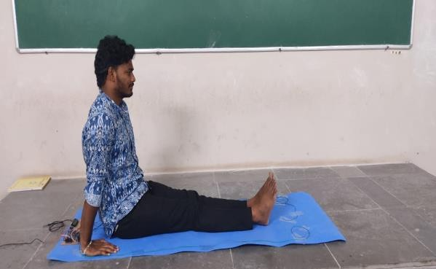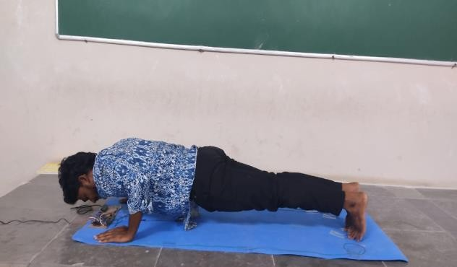
Fig 6.2: Dandasana Fig 6.3: Chaturanga Dandasana

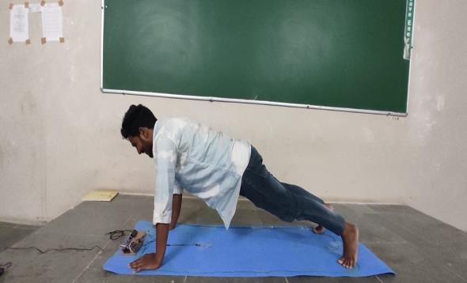
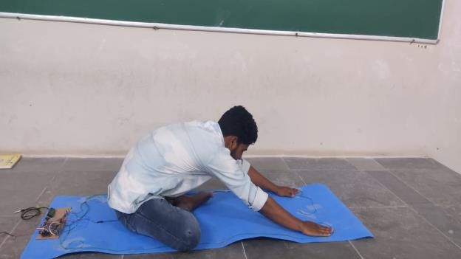
Fig 6.4: Kumbhasana Fig 6.5: Sasakasana

Remote Monitoring Result:
    - Users can view their yoga session in real-time through the Blynk app.
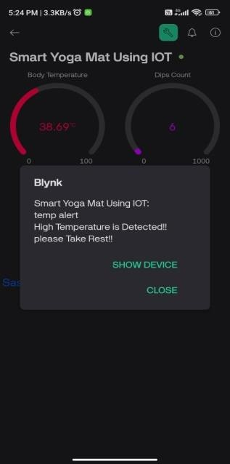
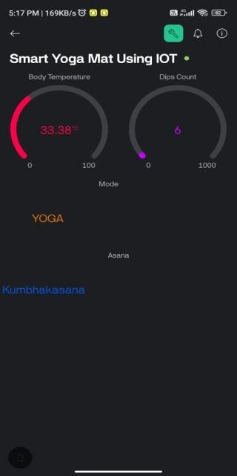
Fig 6.6: Alerting Notification Fig 6.7: Feedback Notification

    - Notifications pop up when wrong poses are detected or if the temperature exceeds safe levels.
    - Session summary (duration, correct/incorrect poses) can be viewed after the session ends.

Final Outcome:
The system successfully:
    - Detects and evaluates the user's yoga poses.
    - Guides the user toward correct posture through visual (LEDs), audible (buzzer), and textual (LCD, Blynk App) feedback.
    - Monitors health metrics like body temperature.
    - Provides a smart, interactive, and IoT-enabled fitness experience.

ADVANTAGES:
    - Real-Time Feedback: Immediate posture and alignment feedback helps users correct their form on the spot, reducing the risk of injury.
    - Enhanced User Engagement: The Blynk IoT app’s interactive interface encourages users to stay motivated and committed to regular yoga practice.
    - Posture Correction: Accurate detection of improper postures through IR and touch sensors allows users to refine their yoga techniques effectively.
    - Improved Balance and Stability: Force sensors provide insights into weight distribution, helping users maintain better balance during complex poses.
    - Temperature Monitoring: DS18B20 sensors ensure users are not overheating, maintaining safety and well-being during intense sessions.
    - Personalized Progress Tracking: Users can analyze their improvements over time through data stored in the cloud, enabling tailored practice routines.
    - Remote Monitoring and Coaching: Yoga instructors can guide students remotely by accessing real-time posture and performance data through the Blynk app.
    - Portability and Ease of Use: The system is compact and user-friendly, suitable for personal, professional, and even clinical environments.
    - Injury Prevention: Continuous monitoring and timely alerts help prevent common yoga injuries related to improper posture and overexertion.
    - Data-Driven Insights: Access to detailed session analytics empowers users to make informed decisions about their health and fitness routines.

APPLICATIONS:
    - Personal Yoga Practice: Assists individuals practicing yoga at home by providing real-time feedback and tracking their improvement over time.
    - Yoga Studios and Training Centers: Enhances traditional yoga classes by allowing instructors to monitor students’ postures digitally and provide personalized corrections.
    - Remote Yoga Coaching: Facilitates virtual yoga classes where instructors can monitor students’ postures and exertion levels remotely via the Blynk app.
    - Rehabilitation Centers: Helps physiotherapists guide patients in performing therapeutic exercises with proper posture and balance.
    - Sports and Athletic Training: Assists athletes in improving flexibility, balance, and body control by ensuring correct posture during stretching and yoga sessions.
    - Corporate Wellness Programs: Encourages employees to engage in guided yoga sessions during work hours, promoting physical and mental well-being.
    - Health and Fitness Research: Provides valuable data for researchers studying body mechanics, posture optimization, and stress management through yoga.
    - Medical Applications: Monitors patients' movements and exertion levels during physiotherapy and post-surgery recovery processes.
    - Elderly Care: Aids senior citizens in performing safe and balanced yoga exercises, preventing falls and improving mobility.

CHAPTER 7 CONCLUSION & FUTURE SCOPE

CONCLUSION
The Smart Yoga Mat project successfully demonstrates the integration of sensor technology with IoT to improve the practice, monitoring, and overall experience of yoga. By embedding a combination of IR sensors, touch sensors, force sensors, and a DS18B20 temperature sensor, the system enables real-time tracking and feedback on key aspects of yoga performance — posture, balance, body contact, and physical stress.
The use of an ESP32 microcontroller for sensor data acquisition and wireless communication, along with the Blynk IoT app for visualization and interaction, creates a user-friendly and accessible solution for yoga practitioners of all levels. The system not only aids in correcting posture errors and ensuring proper weight distribution, but also adds an important health monitoring aspect through temperature sensing.

FUTURE SCOPE:
The Smart Yoga Mat prototype presents a strong foundation for merging IoT with health and fitness, but there are many opportunities to expand its capabilities, functionality, and impact. As technology evolves and user needs grow, the project can be significantly enhanced in the following ways:

Integration of AI/ML for Pose Recognition
      - Implement computer vision using a connected camera and AI algorithms to recognize specific yoga poses.
      - Combine sensor data with machine learning to automatically evaluate posture accuracy and suggest corrections.
      - Personalized recommendations based on user performance trends and body type.

Custom App Development (Beyond Blynk)
      - Move from Blynk to a fully customized mobile application with advanced UI/UX.
      - Include voice assistant integration (e.g., Alexa, Google Assistant) for hands-free guidance.
      - Gamification features: pose challenges, progress milestones, virtual badges.

Mat Design & Sensor Optimization

      - Design flexible, washable, and rollable mats for portability and ease of use.
      - Use textile-based sensors (e-textiles) instead of rigid modules for greater comfort and better data collection.
      - Expand sensor density for full-body tracking in complex poses.

REFERENCES

BOOKS:

- Xu, Wenyao, et al. "ecushion: An etextile device for sitting posture monitoring." Body Sensor Networks (BSN), 2011 International Conference on. IEEE, 2011..

- J. Ismail et al., "Smart prayer mat: a textile-based pressure sensor to assist elderly with cognitive impairment in praying Activity", Proc. of the 5th Int. Conf. on Computing & Informatics, pp. 241-246, Aug.2015.

- Accessed at https://happyhindi.com/wp-content/uploads/2016/07/steps-of -bhujangasana-cobra- pose.jpg on 25th Dec 2018.

- Erica DeMarch , "Balance Sensory and motor Feedback Mat" Patent No. 0128816

- "Yoga Protocol for Control of Diabetes", Ministry of AYUSH, accessed on 25th Dec 2018: https://antidiabetesayush.wordpress.com/2017/05/25/ yoga-protocol-for-control-of-diabetes

LINKS:
- https://www.electronicsforu.com/technology-trends/learn-electronics/ir-led-infrared-sensor- basics
- https://rees52.com/products/30-pin-esp32-development-board-wifi-bluetooth-ultra-low-power- consumption-dual-cores-esp-32-esp-32s-board-rs2282?srsltid=AfmBOopLcJgabY_8MBGc- wukl_pFL1iGlDPqiDh20FhY-pW2H-EBd_-f
- https://rees52.com/products/30-pin-esp32-development-board-wifi-bluetooth-ultra-low-power- consumption-dual-cores-esp-32-esp-32s-board-rs2282?srsltid=AfmBOopLcJgabY_8MBGc- wukl_pFL1iGlDPqiDh20FhY-pW2H-EBd_-f
- https://www.elprocus.com/buzzer-working-applications/
- https://robu.in/product/force-sensor-resistor-square-38-1mm-pressure-sensor/

APPENDIX

CODE:
#define BLYNK_TEMPLATE_ID "TMPL32nIGUXTL"
#define BLYNK_TEMPLATE_NAME "Smart Yoga Mat Using IOT"
#define BLYNK_PRINT Serial #include <Wire.h>
#include <Adafruit_MPR121.h> #include <OneWire.h>
#include <DallasTemperature.h> #include <LCD_I2C.h> #include <WiFi.h>
#include <WiFiClient.h> #include <BlynkSimpleEsp32.h>

// Create MPR121 object
Adafruit_MPR121 mpr121 = Adafruit_MPR121();
LCD_I2C lcd(0x27, 16, 2); // Default address of most PCF8574 modules, change according

// Define ESP32 touch pins #define TOUCH_PIN_1 12
#define TOUCH_PIN_2 13
#define TOUCH_PIN_3 14
const int irSensorPin = 36; // IR sensor pin for counting dips const int switchPin = 35; // Switch pin for mode toggle const int fsrPin = 34; // Force sensor pin for Yoga Mode const int ds18b20Pin = 4; // DS18B20 data pin
const int redLedPin = 26; // Red LED pin for high temp alert const int greenLedPin = 25; // Green LED pin for normal condition const int buzzerPin = 27; // Buzzer pin for alert

int count = 0; // Count variable
int threshold = 1000; // Adjust based on your sensor reading bool objectDetected = false; // Flag for object detection

#define BLYNK_AUTH_TOKEN "h3Y1H3s_SWVE84bhFIHCgefYWlQimP80" char auth[] = "h3Y1H3s_SWVE84bhFIHCgefYWlQimP80";

char ssid[] = "YOGA"; // Enter your wifi name
char pass[] = "123456789"; // Enter your wifi password

// Setup OneWire and DS18B20 Temperature Sensor OneWire oneWire(ds18b20Pin);

DallasTemperature sensors(&oneWire);
//BlynkTimer timer;

void setup() { Serial.begin(115200);
while (!Serial) delay(10); // Wait for Serial Monitor Serial.println("Initializing MPR121 Touch Sensor...");
// Start I2C communication and check if the sensor is detected if (!mpr121.begin(0x5A)) { // Default I2C address Serial.println("MPR121 not found! Check wiring.");
while (1);
}
Serial.println("MPR121 initialized."); pinMode(irSensorPin, INPUT);
pinMode(switchPin, INPUT); // Internal pull-up for switch pinMode(fsrPin, INPUT);
pinMode(redLedPin, OUTPUT); pinMode(greenLedPin, OUTPUT); pinMode(buzzerPin, OUTPUT);

lcd.begin(); lcd.backlight(); lcd.clear(); lcd.setCursor(0, 0);
lcd.print(" Smart Yoga "); // You can make spaces using well... spaces lcd.setCursor(0, 1); // Or setting the cursor in the desired position. lcd.print(" Mat ");
delay(3000);

// Initialize the DS18B20 temperature sensor sensors.begin();

Blynk.begin(auth, ssid, pass);
// timer.setInterval(1000L, sendSensor); delay(2000);
}

void loop()
{
Blynk.run();
//timer.run();
int Smode = analogRead(switchPin); int irValue = analogRead(irSensorPin); int fsrValue = analogRead(fsrPin); sensors.requestTemperatures();

float temperatureC = sensors.getTempCByIndex(0); Serial.print("Temperature: "); Serial.println(temperatureC);

Blynk.virtualWrite(V0, temperatureC);

// Check for high temperature if (temperatureC > 38.0) {
// High temperature alert: turn on red LED and buzzer, turn off green LED digitalWrite(redLedPin, HIGH);
digitalWrite(greenLedPin, LOW); digitalWrite(buzzerPin, HIGH);
lcd.clear(); lcd.setCursor(0, 0);
lcd.print("High Temperature"); lcd.setCursor(0, 1); lcd.print("Detected!");
Blynk.email("anilrebel989@gmail.com", "Alert", "High Temperature is Detected!! please Take Rest!!");
Blynk.logEvent("temp_alert","High Temperature is Detected!! please Take Rest!!"); delay(3000); // Keep the alert active for 3 seconds

// Turn off red LED and buzzer after the alert period digitalWrite(redLedPin, LOW); digitalWrite(buzzerPin, LOW); digitalWrite(greenLedPin, HIGH);
// Return to displaying normal mode information
}
else
{
// Normal condition: turn on green LED digitalWrite(greenLedPin, HIGH); digitalWrite(redLedPin, LOW); digitalWrite(buzzerPin, LOW);
}

if(Smode > 3000)
{
Blynk.virtualWrite(V0, temperatureC); Blynk.virtualWrite(V2,"YOGA");
uint16_t touched = mpr121.touched(); // Get touch state of all MPR121 pins

// Check if MPR121 sensor 0 is touched if (touched & (1 << 0)) {
Serial.println("MPR121 Sensor 0 Touched - Yoga Position 1");
}

// Check if MPR121 sensor 1 is touched if (touched & (1 << 1)) {
Serial.println("MPR121 Sensor 1 Touched - Yoga Position 2");
}

// Read ESP32 touch pins
int left = touchRead(TOUCH_PIN_1); int mid = touchRead(TOUCH_PIN_2); int right = touchRead(TOUCH_PIN_3);

Serial.print("Touch 1: "); Serial.print(left); Serial.print(" | Touch 2: "); Serial.print(mid); Serial.print(" | Touch 3: "); Serial.println(right);

////// Kumbhakasana////

if(touched & (1 << 0) && touched & (1 << 1) && mid < 25 && irValue > 1000)
{ //
lcd.clear();
lcd.setCursor(0,0); // Or setting the cursor in the desired position. lcd.print("Temp: "); // You can make spaces using well... spaces lcd.print(temperatureC); // Or setting the cursor in the desired position. lcd.setCursor(0,1); // Or setting the cursor in the desired position. lcd.print("Kumbhakasana"); // You can make spaces using well... spaces Blynk.virtualWrite(V3,"Kumbhakasana");
delay(3000);
}

////// chaturanga dandasana////
if(touched & (1 << 0) && touched & (1 << 1) && mid < 25 && irValue < 1000)
{
lcd.clear();
lcd.setCursor(0,0); // Or setting the cursor in the desired position. lcd.print("Temp: "); // You can make spaces using well... spaces lcd.print(temperatureC); // Or setting the cursor in the desired position. delay(1000);
lcd.clear();
lcd.setCursor(0,0); // Or setting the cursor in the desired position. lcd.print("Chaturanga ");
lcd.setCursor(0,1); // Or setting the cursor in the desired position. lcd.print("Dandasana"); // You can make spaces using well... spaces Blynk.virtualWrite(V3,"Chaturanga Dandasana");
delay(2000);
}

////// SASANKASANA////

if(left < 23 && right < 23 && mid < 25 && fsrValue > 3500)
{
lcd.clear();
lcd.setCursor(0,0); // Or setting the cursor in the desired position. lcd.print("Temp: "); // You can make spaces using well... spaces lcd.print(temperatureC); // Or setting the cursor in the desired position. delay(1000);
lcd.setCursor(0,1); // Or setting the cursor in the desired position. lcd.print("SASANKASANA"); // You can make spaces using well... spaces Blynk.virtualWrite(V3,"Sasankasana");
delay(2000);
}

//////dandasana////

if(touched & (1 << 0) && touched & (1 << 1) && mid < 25 && fsrValue > 3500)
{
lcd.clear();
lcd.setCursor(0,0); // Or setting the cursor in the desired position. lcd.print("Temp: "); // You can make spaces using well... spaces lcd.print(temperatureC); // Or setting the cursor in the desired position. lcd.setCursor(0,1); // Or setting the cursor in the desired position. lcd.print("Dandasana"); // You can make spaces using well... spaces Blynk.virtualWrite(V3,"Dandasana");
delay(3000);
}

else
{
lcd.clear(); lcd.setCursor(0, 0);
lcd.print("Smart Yoga Mat"); // You can make spaces using well... spaces lcd.setCursor(0, 1); // Or setting the cursor in the desired position. lcd.print(" YOGA Mode ");
delay(1000);
}
}

else /// GYM Mode
{
lcd.clear(); lcd.setCursor(0, 0);

lcd.print("Smart Yoga Mat"); // You can make spaces using well... spaces lcd.setCursor(0, 1); // Or setting the cursor in the desired position. lcd.print(" GYM Mode ");

delay(100);
int irValue = analogRead(irSensorPin); // Read analog value from IR sensor Serial.print("IR Value: ");
Serial.println(irValue);

// If object is detected (IR value drops below threshold) if (irValue < threshold && !objectDetected) {
count++; // Increment count
objectDetected = true; // Set flag to avoid multiple counts
Serial.print("Count: "); Serial.println(count);
lcd.clear();
lcd.setCursor(0,0); // Or setting the cursor in the desired position. lcd.print("Temp: "); // You can make spaces using well... spaces lcd.print(temperatureC); // Or setting the cursor in the desired position.

lcd.setCursor(0, 1); lcd.print("Dip Count:"); lcd.print(count);
Blynk.virtualWrite(V0, temperatureC); Blynk.virtualWrite(V1,count); Blynk.virtualWrite(V2,"GYM"); Blynk.virtualWrite(V3,"DIPS");
}

// Reset flag when object moves away (IR value rises) if (irValue > threshold) {
objectDetected = false;
}
delay(100); // Small delay to improve stability
}
}

